Nasal Mupirocin Ointment Instructions
Use TWICE DAILY
Monday-Friday, EVERY OTHER WEEK
Step 1: Clean nostrils (including tip) with tissue prior to application
Step 2: Turn tube cap counter-clockwise
Step 3: Tilt your head back
Step 4: Apply a pea size amount of mupirocin into
each nostril

Step 5: Cotton swab may help to distribute ointment
Step 6: Press nostrils together and massage for 1 minute
Step 7: Avoid contact with eyes and other nose products

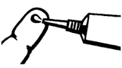
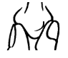
Preventing infection is important

for 6 months after hospital discharge.

See sample prescription to discuss with your doctor.

