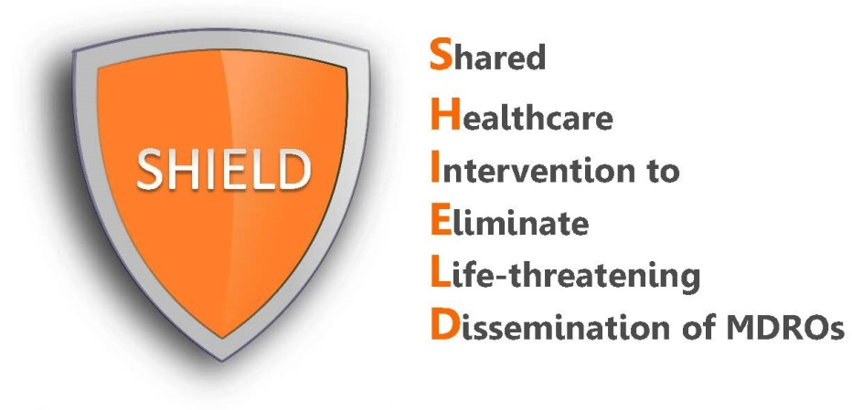
Nursing Protocol:
Bathing with 2% No-Rinse Chlorhexidine Cloths

Before Launching Chlorhexidine (CHG) Intervention
Perform One-Time Skin Check: Prior to launching CHG intervention, check for and document skin lesions, wounds or rashes. Staff may be more attentive to residents’ skin when starting to use a new soap and may misattribute skin issues to CHG that already existed previously.
Who should receive chlorhexidine?
- Adult patients in long-term acute care hospitals (LTACHs)

Excluded patients
- Known allergy to chlorhexidine (CHG)

Protocol for Bed Bathing with 2% Chlorhexidine No-Rinse Bathing Cloths
- CHG bathing or shower to be provided on admission followed by bathing and showering per routine schedule.
- Provide one-page CHG information sheet for patients to read prior to initial CHG cloth bath. These information sheets do not replace verbal instruction, but they save time and allow reinforcement of information already read.
- Pre-Bath: Clean all incontinence or gross soilage using a CHG compatible baby wipe or cloths with water. Do not use soap which can inactivate CHG. Ensure trash can nearby. Determine number of cloths needed.
- Cloths may be used at room temperature or warmed for comfort based upon patient preference. If warmth desired, do not remove cloths from warmer until patient is fully ready for bath.
- Just before bath, remove one set of warmed packets (3 packets in a set, 2 cloths per packet for a total of 6 cloths) of 2% CHG cloths from the warmer. Removed packet should have a “ready” light illuminated to confirm fully warmed.
- For obese patients, additional cloths may be needed. Take extra single 2-cloth packets until the needed number is reached.
- Educate the patient that the CHG cloths work better than soap and water in removing bacteria from the skin and that the cloths serve as their protective bath.
- If the patient wishes to self bathe, provide verbal instructions, and assist with hard to reach areas. Refer to “Patient Talking Points” file for an example of verbal instructions for patients as well as how to encourage bathing. Self-bathers will need assistance with cleansing of any wounds and devices.
- Regardless of patient size, use ALL of the 6 cloths for bathing the following body areas. Both sides of the cloth should be used.
- Ensure that cloths are applied to skin by firm massage to ensure binding of CHG to skin proteins, which allows it to continue to kill germs for a minimum of 24 hours.
  - Cloth 1: Face, neck, and chest. Avoid eyes and ears.
  - Cloth 2: Both shoulders, arms, and hands
  - Cloth 3: Abdomen and then groin/perineum
  - Cloth 4: Right leg and foot
  - Cloth 5: Left leg and foot
  - Cloth 6: Back of neck, back and then buttocks
  - Once opened, cloths should be kept on the blue insulator for warmth until used. Do not place cloths directly onto sheets as this will produce a brown stain when combined with bleach in the laundry.
  - After use on assigned part of body, use a clean part of the cloth to clean devices on that part of the body within 6 inches of the patient, including central lines, urinary catheters, drains, G-tube/J-tubes, rectal tubes, chest tubes.
  - Wipe over non-gauze dressings. This will help remove bacteria where devices penetrate the skin. CHG is safe on devices and can be used over occlusive and semi-occlusive dressings.
  - Allow to dry naturally. Do not wipe off.
  - CHG cloths have moisturizers. If additional moisturizer or lotion is needed, only use lotions that are compatible with CHG.
  - Do not place CHG cloths directly on bedding as contact with bleach during the washing process can leave brown stain. Once CHG is applied to the skin, it binds skin proteins and will not rub off onto bedding.
  - Dispose of CHG cloths in trash. Do not flush in commode.
  - Post-Bath
    - Incontinence episodes: Remove soiled incontinence using CHG-compatible baby wipes, disposable cloths, or towels. If necessary, rinse off the affected area with water. Then, reapply CHG using a single packet of 2-cloths. Single packs should be kept in a row in the warmer for easy availability. Use these additional packets as needed during the day.
    - If barrier protection is needed, be sure to use CHG-compatible barrier protection products after CHG is applied.
IMPORTANT REMINDERS for CHG Cloth Bathing
- Do not use regular soap with CHG. Many soaps inactivate chlorhexidine. CHG works better than soap and water in deeply cleansing the skin.
- Ensure thorough cleaning, with special attention to commonly soiled areas such as the neck, skin folds, and perineal areas. CHG is safe to use on perineal areas, including external mucosa.
- For candidal rashes, note that CHG is active against candida. However, be sure that the CHG is dry between body folds. Fan the area with the blue insulator to aid drying. If not completely dry, rashes may worsen.
- CHG is safe for superficial wounds, including stage 1 and 2 decubitus ulcers, superficial burns, as well as rashes and abrasions. These areas are at high risk for infection and CHG kills germs and helps prevent infections. Do not use on large or deep wounds, (e.g. packed wounds).
- Use CHG for all bathing purposes, including full-body bathing, cleaning after incontinence clean up, or any other reasons for additional cleaning. This includes the face; however avoid contact with eyes and ears.
- If moisturizer is needed, provide patient with CHG-compatible lotion.
- Allergic reactions are rare, but can occur. If a patient experiences a reaction possibly related to CHG product, contact the patient’s treating physician for all clinical decisions on whether to stop the product or provide any medication to address a possible reaction.
- Maintain facility policies for covering devices, including dressings to prevent water penetration and introduction of water borne bacteria.

