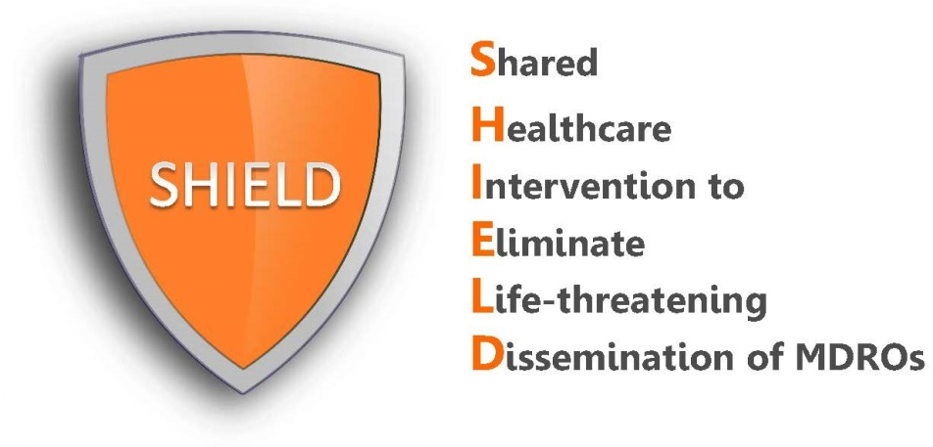

Patient Talking Points
Nasal Iodophor

Patients may have questions regarding nasal iodophor. Below are some suggested responses to common patient questions.

REMEMBER:
- Your enthusiasm and encouragement will be the greatest predictor of a patient’s acceptance and support for the protocol.
- Exclude patients with known allergy to iodine.

- How to introduce iodophor swabs to patients:
“Good morning Ms/Mr X, our hospital provides all patients on contact precautions with iodophor swabs to remove bacteria from the front of the nose. Some bacteria that you may have heard of, like "MRSA," live in the front of the nose. Patients who have MRSA in the nose can develop serious infections such as pneumonia, bloodstream, and skin and soft tissue infections. Thus, we want to protect all our patients from infection by giving this swab to get rid of those germs. Would that be okay?

Have you had this swab in your nose before? It's called iodophor, also known as povidone iodine. We use one swab in each nostril for about 30 seconds, or at least 3 times around slowly.

Our doctors are offering this to all patients Monday-Friday every other week. We give it twice a day. The goal is to protect all patients at the same time.

- How to answer some possible questions from patients:
- Will this make my nose brown?
“It is possible for iodophor to leave a brown tinge just on the outer edge of the nose, but we can use a tissue to dab that off if it bothers you.”

- Why does it need to be given twice a day?
“Iodophor needs to be given twice a day for 5 days because it takes multiple doses to help get rid of MRSA and other bacteria.”

- Why do we get to skip a week?
“After a 5 day course, most people’s noses stay clear of bacteria for about a week, which is why we give a week off.”

- Why can’t you screen patients to know who actually has MRSA and give it to just those who have it?
“There are several reasons why we give the iodophor swabs to all patients together. First, MRSA is contagious, which means that it could be easily transferred from one patient to another. Second, screening swabs are not perfect and they only tell us if MRSA is in the nose at the time of the swab. Third, in addition to MRSA, the swabs help with other types of bacteria. Second, patients on contact precautions for one antibiotic resistant bacteria are likely to have other types of resistant bacteria. These swabs help reduce MRSA, in addition to the non-resistant form of this bacteria.”

