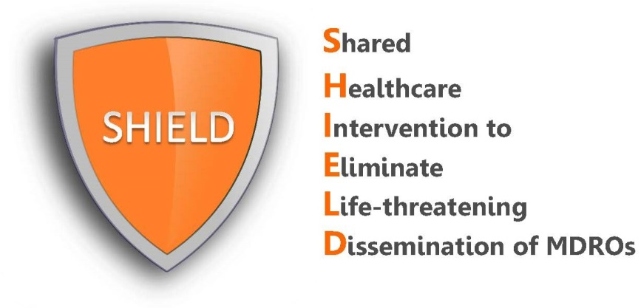

Nursing Home Protocol Post-Training Test:
Chlorhexidine bathing with cloths
and nasal iodophor administration

Date: _________________ Title (circle one): CNA LVN RN OTHER: ____________________

Name: _________________________________ Signature: ______________________________

- What is the SHIELD Program?
  - A quality improvement program to reduce multi-drug resistant organisms (MDROs) like MRSA and ESBL in nursing homes
  - A research project to minimize the spread of multi-drug resistant organisms
  - A project to evaluate novel decolonization products for FDA clearance
  - An initiative to improve bathing techniques for all residents

- Who should receive the decolonization "cleansing" protocol?
  - MRSA-positive residents
  - Residents on contact precautions
  - Residents who stay longer than 2 weeks
  - All residents over 18 years old

- Which of the following is correct when using chlorhexidine cloths?
  - Apply chlorhexidine cloths to the skin and then bathe with soap and water
  - Bathe with soap and water then apply chlorhexidine
  - Bathe with chlorhexidine cloths and let air dry

- Chlorhexidine cloths can be used on all of the following EXCEPT:
  - Lines, tubes, and drains within 6 inches of the body
  - Superficial decubitus ulcers (stage 1&2)
  - Large or deep wounds
  - Sutured or stapled wounds
- Which dressings should be cleaned with chlorhexidine?
  - Gauze dressings
  - Semi-permeable or occlusive dressings

- Why are the chlorhexidine cloths warmed?
  - To make the chlorhexidine work against germs
  - For comfort only

- What should be done if the light on the CHG cloth warmer says "discard"?
  - Nothing. The lights aren't important.
  - Use that chlorhexidine pack right away for the next resident who needs a bath
  - Throw that chlorhexidine pack away because it has been in the warmer too long and may not work

- Chlorhexidine cloths can be re-warmed AFTER being taken out of the warmer.
  - True
  - False

- Who should receive nasal iodophor?
  - Nasal iodophor should be given to MRSA-positive residents only
  - Nasal iodophor should be given to all residents on contact precautions
  - Nasal iodophor should be given to all residents

- Which of the following is correct when using nasal iodophor?
  - Apply once to each nostril
  - Apply twice daily to each nostril for five days
  - Apply only to residents known to have MRSA

Nursing Home Protocol Post-Training Test Answer Key:
Chlorhexidine bathing with cloths
and nasal iodophor administration

- A

- D

- C

- C

- B

- B

- C

- B

- C

- B

