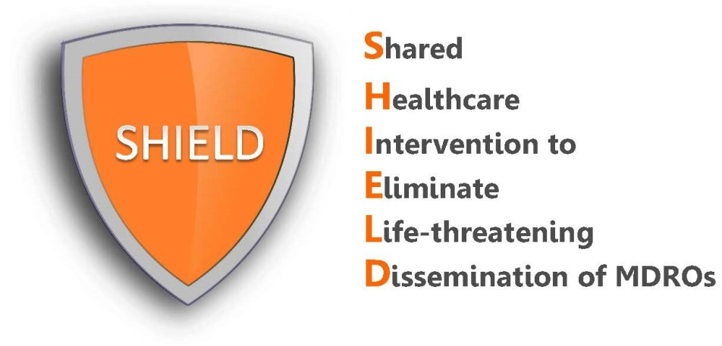

Resident Talking Points
Nasal Iodophor

Residents may have questions regarding nasal iodophor. Below are some suggested responses to common resident questions.

REMEMBER:
- Your enthusiasm and encouragement will be the greatest predictor of a resident’s acceptance and support for the protocol.
- Exclude residents with known allergy to iodine.

- How to introduce iodophor swabs to residents:
“Good morning Ms/Mr X, every other week, our nursing home provides all residents with iodophor swabs to remove bacteria from the front of the nose. Some bacteria that you may have heard of, like "MRSA," live in the front of the nose and can cause future infections. Studies have found that one-third to one-half of nursing home residents have MRSA so we want to protect all our residents from infection by giving this swab to get rid of those germs. Would that be okay?

Have you had this swab in your nose before? It's called iodophor, also known as povidone iodine. We use one swab in each nostril for about 30 seconds, or at least 3 times around slowly.

Our doctors are offering this to all residents Monday-Friday every other week. We give it twice a day. The goal is to protect all residents at the same time.
- How to answer some possible questions from residents:

- Will this make my nose brown?
“It is possible for iodophor to leave a brown tinge just on the outer edge of the nose, but we can use a tissue to dab that off if it bothers you.”

- Why does it need to be given twice a day?
“Iodophor needs to be given twice a day for 5 days because it takes multiple doses to help get rid of MRSA and other bacteria.”

- Why do we get to skip a week?
“After a 5 day course, most people’s noses stay clear of bacteria for about a week, which is why we give a week off.”

- Why can’t you screen residents to know who actually has MRSA and give it to just those who have it?
“There are several reasons why we give the iodophor swabs to all residents together. First, MRSA is contagious. Studies have shown that 30-50% of nursing home residents have MRSA, so it is important to treat everyone together. Second, screening swabs are not perfect and they only tell us if MRSA is in the nose at the time of the swab. Third, in addition to MRSA, the swabs help with other types of bacteria.”

