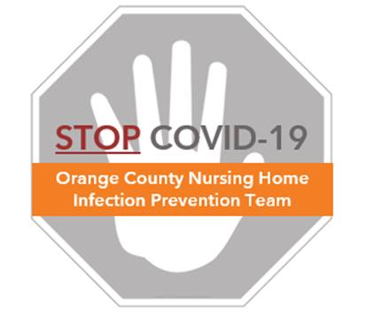

**Visitor Policy**

**Frequently Asked Questions (FAQs)**

**Why are visitors being restricted during this time?**

* Many of our residents are elderly and may have medical conditions putting them at a very high risk of becoming sick, or even severely ill, with COVID-19. During a pandemic, visitors and staff are the most likely sources of bringing COVID-19 from the community into our nursing home.
* To protect the health and safety of nursing home residents and staff, the California Department of Public Health (CDPH) recommends that long-term care facilities temporarily modify their facility’s visitation policies, in accordance with national guidance from the Centers for Disease Control and Prevention (CDC) and the Centers for Medicare and Medicaid Services (CMS).

**What is the recommended policy for visitors?**

* Per CDC, CMS, and CDPH guidance, visitors should not be allowed at this time. This is a necessary action to protect the health of all residents. This visitor restriction includes volunteers and non-essential personnel (eg. hair stylists, barbers).
* For vendors and suppliers who must deliver to the building, have supplies dropped off at a dedicated location outside the facility (e.g., loading dock).
* All persons who enter the facility must wear a face mask and undergo a temperature and symptom screen for symptoms of COVID-19. We recommend the following symptom screen:

**A person has a POSITIVE symptom screen, if they have any of the symptoms below:**

* Fever $≥$ 99.0
* Chills
* New cough
* New shortness of breath
* Muscle aches
* Unexpected fatigue
* Sore throat
* Loss of taste or smell
* Headache
* Diarrhea
* Vomiting
* Nausea
* Other cold symptoms

**How can we help residents stay connected with loved ones?**

* Facilities should offer alternative methods of visitation (such as phone, Skype, and FaceTime) to help residents stay connected with loved ones
* Create a schedule with designated staff for coordinating calls between residents and family members
* Keep record of up-to-date contact information to inform and update families on these policies. Consider setting up a phone line with a voice recording to streamline updates.

**Are there exceptions for end of life circumstances?**

* On a case by case basis, visitors may be allowed for end of life circumstances
* Only one visitor should be allowed into the facility at a time, and all visitors must first be screened on entry for fever or any symptoms (see above). No ill visitors will be allowed.
* Visitors will be required to mask, clean their hands with alcohol hand rub on entry, and be escorted directly to the room and then back out again.
* If the resident has no required precautions, once in the room, the visitor’s mask may be removed until the visit is over. The mask must be worn again to exit the facility.
* If the resident requires a mask or other precautions to be worn, then the visitor must wear protective gear as directed.