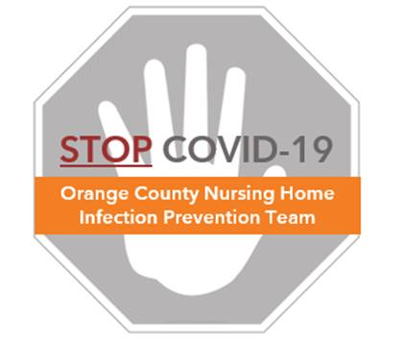

**Preventing COVID-19 in Nursing Homes**

**Aerosol Generating Procedures Protocol**

**Aerosol Generating Procedures (AGPs)**

* Aerosol generating procedures, or AGPs, are those performed on a person with a contagious respiratory disease in which a healthcare worker could potentially be exposed to very small particles of a communicable disease pathogen.
* To be considered an AGP, the procedure must include all three of the below:
  + Involves the respiratory tract PLUS
  + Involves a resident with contagious respiratory symptoms PLUS
  + Involves a procedure that generates aerosols (very small particles that hang in the air) around the operator

**AGPs in Residents with COVID-19**

* COVID-19 is spread by droplets and is not considered an airborne disease. However, some procedures can generate very small particles that can hang in the air and be inhaled. See the document called “FAQ – Aerosol Generating Procedures.”
* The list provided in this document outlines procedures for which an N95 respirator should be used.
* WHO, CDC, and CalOSHA do not require AGPs in airborne rooms if not available

**Use an N95 RESPIRATOR when performing any of the following procedures in residents with contagious respiratory symptoms:**

**Ventilation**

* Cardiopulmonary resuscitation
* Intubation
* Extubation
* Manual ventilation
* Non-invasive positive pressure ventilation (BiPAP, CPAP)
* Disconnection of ventilator circuits (e.g., changing ventilator tubing)

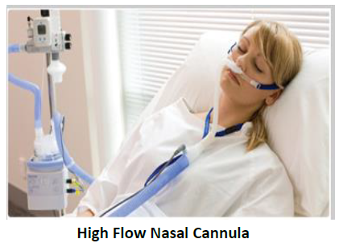

**Respiratory Therapy Procedures**

* Sputum induction
* Open airway suctioning, such as tracheostomy suctioning (not in-line suctioning or suctioning of oral mucosa)
* 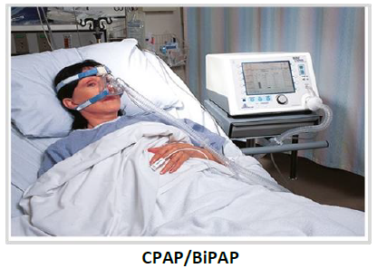Nebulizer therapy (use metered dose inhalers (MDI) instead, when possible)
* High flow nasal cannula (HFNC) oxygen (>15L)
* Non-invasive positive pressure ventilation (BiPAP, CPAP)

**Use STANDARD MASK in Residents With Contagious Respiratory Symptoms For:**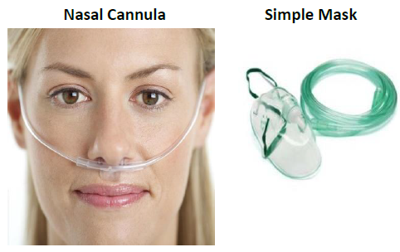

* Oral care, hygiene
* Suctioning in the mouth
* Nasogastric tube insertion
* Conventional nasal cannula oxygen treatment
* Non-rebreather mask/treatment
* Chest physiotherapy (including vest therapy and external percussive devices)
* 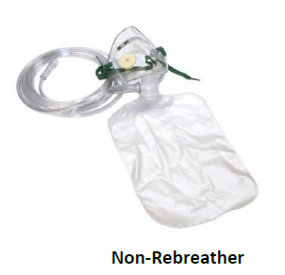Cough assist