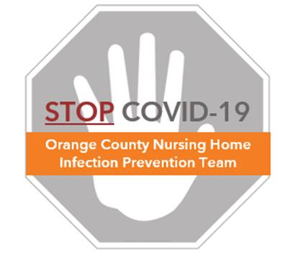

**Preventing COVID-19 in Nursing Homes**

**Eye Protection Reuse and Extended Use Protocols**

Protecting the supply of personal protective equipment (PPE) is important to assure the current and future health of residents and healthcare workers.  **Safe re-use can and should be encouraged.**

**Definitions:**

**Reuse** refers to the practice of using the same PPE for multiple encounters with different residents, but removing it (‘doffing’) after each encounter.

**Extended** use refers to the continuous wear of the same PPE (e.g., face shield) for serial or repeated close contact encounters involving multiple residents, without removing the PPE between resident encounters. For the COVID-19 pandemic, extended use is only appropriate for designated locations where all residents are diagnosed with COVID-19.

***NOTE: If splash, spray, or aerosol generation occurs, treat eye protection as single use and discard unless all surfaces of the eye protection can be fully disinfected.***

**Reuse of Eye Protection – General Principles**

* Eye-protection can be reused and used for extended periods safely
* Goggles are designed for extended use and re-use and can be reused for months
* Face shields can be reused as long as it is not damaged in any way (e.g. warped/soiled, face shield cracked/ripped, not clear for viewing), maintains adequate fit, and does not have direct splash or spray that would prevent adequate disinfection
* Perform hand hygiene every time before and after touching your protective eye gear

**How to Safely Reuse Eye Protection**

* Follow the doffing protocol for goggles, safety glasses, or face shields (See “COVID Eye Protection Protocol”), assuring hand hygiene is done before and after touching any protective eye gear
* **Goggles or Safety Glasses:** 
  + Use alcohol pads to thoroughly clean and allow to dry. Alcohol dries fast without streaking. Disinfectant wipes can also be used provided they do not leave a film that obscures view.
  + Store in a clean, dry location when not being used.
* **Face shields:**
  + Label face shield with marker and keep it in a clean convenient place for use.
  + Clean face shield with alcohol prep pad or disinfectant wipes allow to dry.
  + Store face shield in a clean, dry location when not being used.
* NOTE: because face shields prevent masks from becoming contaminated from spray or splash, face shields have advantages over goggles or safety glasses.

**Extended Use of Eye Protection – General Principles**

* Extended use (continuous wear between multiple residents) is only allowed in dedicated COVID areas where all residents within that zone (e.g. RED Zone) have confirmed COVID by PCR testing.
* All forms of eye protection (face shields, goggles, safety glasses) may be used for extended use.
* If splash, spray, damage or loss of fit occurs at any time, the eye protection needs to be discarded (or fully disinfected if all surfaces can be disinfected) and a clean one put on.
* Avoid touching the eye protection as much as possible.
* If readjustment of the eye protection is needed, perform hand hygiene every time before and after touching your protective eye gear

**How to Safely Practice Extended Use of Eye Protection**

* Don goggles, safety glasses, or face shields (See “COVID Eye Protection Protocol”) upon entry to the dedicated area where extended use is permitted, assuring hand hygiene is done before and after touching any protective eye gear
* Note that while extended use is permitted for masks, eye protection, and gowns between residents in the COVID Dedicated Area (e.g. RED Zone), gloves should be changed between residents and hand hygiene should be performed each time between residents. Glove exchange and hand hygiene should continue to be performed per usual best practice:
* before touching a resident,
* before clean/aseptic procedures,
* after any soiled activity, such as incontinence care, bathing, and body fluid exposure/risk,
* after touching a resident, and.
* after touching resident surroundings.
* Upon leaving the area, doff goggles, safety glasses, or face shields (See “COVID Eye Protection Protocol”). Clean eye protection according to re-use processes delineated above and store in a clean bag for next re-entry or use. If unable to be cleaned, damaged or no longer fits, discard.