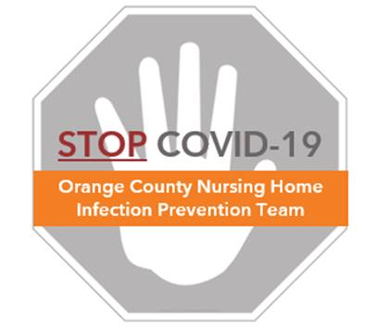

**Preventing COVID-19 in Nursing Homes**

**Standard Mask Protocol**

**Standard Masks**

* Refers to a surgical mask
* Fluid resistant
* Designed to provide a barrier against droplets, sprays, or splashes
* Covers your nose and mouth

**When to Use Standard Masks During COVID Care**

* Standard surgical masks should be used whenever providing direct resident care
* Community cloth masks may be worn during non-resident care activities
* Reserve N95 respirators for aerosol generating procedures (eg. CPR, nebulizer treatment, tracheostomy suctioning) – see “N95 Respirator Protocol”

|  |  |  |
| --- | --- | --- |
| **Who** | **What** | **Where** |
| Non-direct care providers | Community cloth mask | On arriving and leaving work  and continuously through the day |
| Direct care providers | Community cloth mask | On arriving and leaving work  Non-resident care areas  During administrative time (not providing resident care for all or part of day)  During breaks |
| Direct care providers | Surgical/standard mask | Can be worn continuously in resident rooms or during resident care duties |

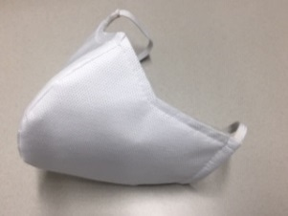 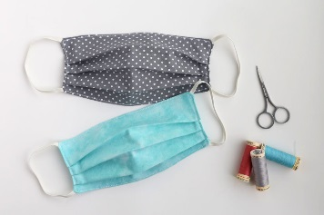 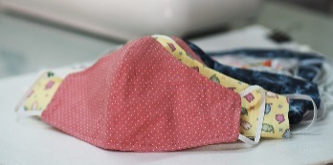

Examples of community cloth masks

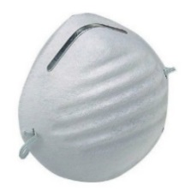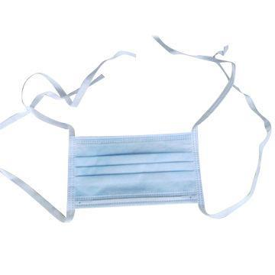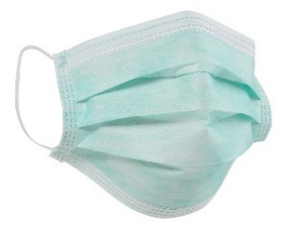

Examples of resident care masks

**Donning (Putting On) a Standard Mask**

* Clean your hands with alcohol hand sanitizer or soap/water
* Remove mask from the box or your paper or plastic bag containing your surgical mask
* Orient the mask with the stiff bendable edge (nosepiece) on top; usually the colored side of the mask is the front and should face away from you, and the white side touches your face
* Follow the instructions below depending on the type of mask you are using.
  + **Face Mask with Ear loops**: Hold the mask by the ear loops. Place a loop around each ear.
  + **Face Mask with Ties**: Bring the mask to your nose level, place the ties over your head, secure by tying the top straps to the back of your head and the bottom straps to the back of your neck.
  + **Face Mask with Bands**: Hold the mask in your hand with the nosepiece or top of the mask and bring the mask to your nose level; pull the top strap over your head so that it rests over the top, back part of your head. Pull the bottom strap over to the nape of your neck below the ears.
* Mold or pinch the stiff edge to the shape of your nose.
* Clean your hands
* 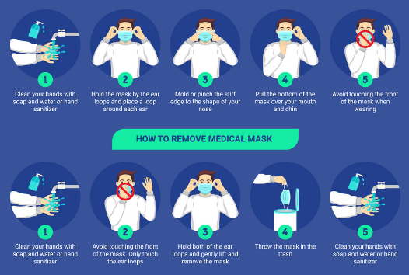Your mask should always cover both your nose and mouth. Do not hang your mask on one ear or under your chin.

**Doffing (Taking Off) a Standard Mask**

* Clean your hands with alcohol hand sanitizer or soap/water
* Avoid touching the front of your mask and only touch the ear loops/ties/band
* Follow the instructions below depending on the type of mask you are using.
  + **Face Mask with Ear loops**: Hold both ear loops, gently lift and remove the mask.
  + **Face Mask with Ties**: Untie the bottom straps first then untie the top straps, pulling the mask away from you as the ties are loosened.
  + **Face Mask with Bands**: Lift the bottom strap over your head first then pull the top strap over your head.
* Store your surgical mask in a clean paper bag or a thin plastic bag that is kept open to air (not sealed) (See “Surgical Mask Reuse Guidance”)
* Replace the mask if it becomes wet, soiled, damaged, or does not fit properly
* Clean your hands after removing and storing/discarding mask

**Keeping Your Face Mask Clean**

* Perform hand hygiene every time before and after touching your face mask
* In general, avoid touching your mask, especially the inside of the face mask
* Use a face shield when caring for COVID-19 residents to prevent your mask from being contaminated, allowing safe mask reuse (see “Mask Reuse Protocol”)