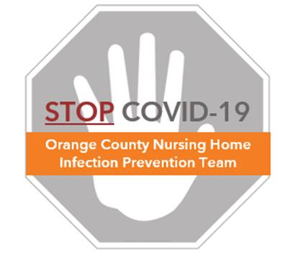

**Preventing COVID-19 in Nursing Homes**

**Housekeeping Cart, Supplies and Setup**

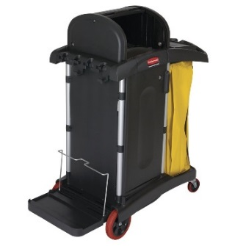

**Housekeeping Cart**

* Carts should be lightweight, easy to steer, and easy to be cleaned
* The cart should have enough space to store all cleaning supplies for a shift
* Dedicate time to organize and stock the cart

**Housekeeping Cart Inventory**

* It is important that all supplies and chemicals are ready to use
* Use the table below to ensure supplies are stocked:

|  |  |
| --- | --- |
| **Supplies** | |
| Cleaning Cloths | Alcohol-based Hand Sanitizer |
| Disinfectant Bin | Surgical Masks |
| Wet Mop Bucket & Handle | Face Shield |
| Wet Mop Heads | Disposable Gloves |
| Dust Mop Handle | Paper Towels |
| Dust Mop Heads | Trash Bags |
| Dust Broom & Pan | Toilet Brush and Holder |
| High Duster | Toilet Paper |
| Soiled Linen Bag | Safety Goggles (for filling chemicals bottles) |

|  |
| --- |
| **Chemicals** |
| Commercial-grade Disinfectant |
| Neutral Floor Cleaner |
| Glass Cleaner |
| Lime Scale Remover |
| Bleach Wipes (for Contact Precaution rooms) |
| Toilet Bowl Cleaner |

**Housekeeping Cart Preparation and Setup**

* Use the table below to set up the housekeeping cart

|  |  |  |
| --- | --- | --- |
| **Top of Cart** | **Inside Cart** | **Front Deck** |
| Disinfectant Bin | Disinfectant Refill Bottles | Wet Mop Bucket and Handle |
| Pumice Stick | Additional Cleaning Cloths | Dust Mop Handle |
| Surgical Masks | Mop Heads (Dry and Wet) | Dust Broom & Pan |
| Alcohol Based Hand Sanitizer | Bleach Wipes | High Duster |
| Face Shield | Glass Cleaner | Toilet Brush & Holder |
| Disposable Gloves | Lime Scale Remover | Soiled Linen Bag |
|  | Paper Towels | Trash Bag |
|  | Toilet Paper |  |
|  | Trash Bin Liner Refills |  |

* At the end of every shift, remove supplies and disinfect each cart
  + Even though the carts carry disinfectant, it doesn’t mean the cart is clean
  + Remember carts move all over the nursing home, so disinfect it prior to use
  + Wipe down inside and outside of cart with a saturated disinfectant cloth
* Once cleaned, load cart with supplies and chemicals needed for the next shift

**Housekeeping Cart Dos and Don’ts**

|  |  |
| --- | --- |
| **DO** | **DON’T** |
| * Clean your cart after your shift * Keep surgical masks, gloves, face shield and alcohol-based hand sanitizer available on cart for use as needed to clean hands and protect against splash or spray * Wear safety goggles or a face shield when filling up buckets/bins with chemicals * Clean bottles and bins when visibly soiled | * Do NOT store personal items or food on or inside of cart * Do NOT leave cart unattended during your shift, unless locked and stored * Do NOT push cart into resident rooms * Do NOT combine clean and soiled items |