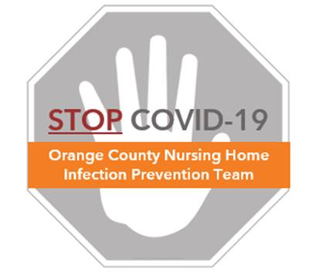

**Preventing COVID-19 in Nursing Homes**

**Protocol – Housekeeping Observations**

**Skills Assessment**

* The supervisor should observe housekeepers cleaning while using a checklist (see “Housekeeping Skills Assessment Log”)
* This method is helpful to see if housekeeping staff are following cleaning guidelines, such as the clean-to-dirty technique and not skipping any surfaces
* Housekeeping skills assessments require little preparation and are free to complete

**Frequency**

* It is important to complete a housekeeping skills assessment at least once per week for each housekeeper to create and maintain routine
* If a housekeeper fails the assessment, it is beneficial to provide feedback and re-test that same week

**Method**

* Watch housekeeper clean a room or area from start to finish using the “Housekeeping Skills Assessment” log
* As cleaning proceeds, record the names of the surfaces that have been completed
* Once cleaning has finished, record any surfaces that were not cleaned at all or that were cleaned poorly
* Provide feedback to the housekeeper