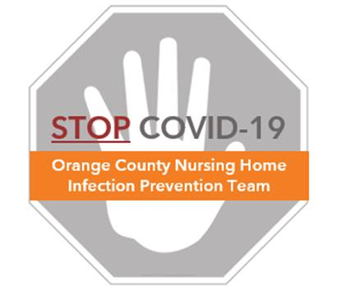

**Preventing COVID-19 in Nursing Homes**

**Protocol – Resident Room Cleaning**

**Cleaning Guidance**

* Clean surfaces in a fixed order to create a cleaning routine
* Clean standard-care resident rooms before proceeding to contact precaution rooms
* Assign a specific color cleaning cloth to different room types
  + Example: green for resident room, blue for bathroom, purple for common areas
* Proceed from cleanest to dirtiest to reduce the likelihood of transferring dirt and germs from one surface to another
  + In a resident room, cleaning should start with items further away from resident and least-frequently touched (such as light switch) and proceed closer to the resident (such as over bed table and remotes)

**Resident Room Example**

* The following picture shows a clean-to-dirty sequence for room cleaning
  + **Numbers** show the order in which the surfaces are cleaned
  + **Arrows** represent the way a housekeeper will navigate through the room
  + 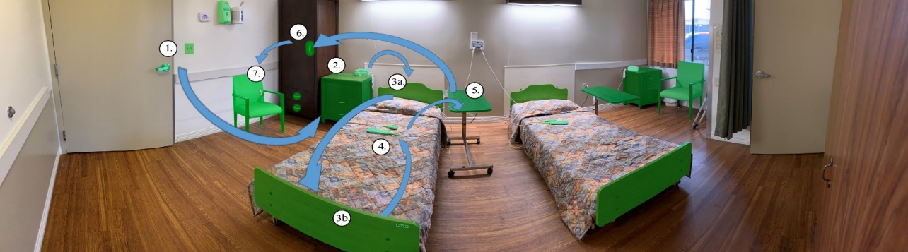High-touch surfaces to be cleaned are colored in **green**

**Resident Room Cleaning**

* High-touch surfaces in resident rooms include: light switch, door handle, headboard and footboard of bed, call button/TV remote/bed remote, nightstand, over bed table, and guest chair

|  |  |  |
| --- | --- | --- |
| **High-touch Surfaces in Resident Rooms** | | |
| /Users/chaseberman/Downloads/jpegmini_optimized (2)/IMG_1877.jpg | C:\Users\cberman1\Desktop\CLEAN\Cleaning Protocol\Images\TACM\Resident Room\Footboard.jpg | /Users/chaseberman/Downloads/jpegmini_optimized (2)/IMG_1719.jpg |
| Door Knob and Light Switch | Headboard and Footboard | TV/Bed Remote |
| /Users/chaseberman/Downloads/jpegmini_optimized (2)/IMG_1721.jpg | ../../../Downloads/jpegmini_optimized%20(2)/IMG_1742.jpg | ../../../Downloads/jpegmini_optimized%20(2)/IMG_1874.jpg |
| Nightstand | Over Bed Table | Guest Chair |

* Resident room cleaning steps:
  1. Perform hand hygiene and don fresh gloves
  2. Take a freshly saturated clean cloth and fold twice, to make 8 sides for cleaning (see “Protocol – Folding Cleaning Cloths”)
  3. Use one side of the cloth to wipe door knob and light switch
  4. Use opposite side to wipe headboard, footboard, and any bed rails
  5. Unfold cleaning cloth to a clean side, and wipe bed remote, TV remote, and call light/button
  6. With another clean side, wipe nightstand with emphasis on drawer handles
  7. With another clean side, wipe over bed table
  8. With another clean side, wipe guest chair and any additional items in room
  9. Remove trash can liner, clean inside and outside of trash can, and replace liner
  10. Place used cleaning cloth in linen bag
  11. Remove gloves and wash hands with soap and water to remove any chemicals

**Resident Bathroom Cleaning**

* High-touch surfaces in resident bathrooms include: light switch, door knob, faucet handles, wall dispensers, wall handrails, toilet flush handle, portable toilet chair, toilet seat

|  |  |  |
| --- | --- | --- |
| **High-touch Surfaces in Resident Bathrooms** | | |
| /Users/chaseberman/Downloads/jpegmini_optimized (2)/IMG_1877.jpg | C:\Users\cberman1\Desktop\CLEAN\Cleaning Protocol\Images\Bathroom Images\Sink and Towel Dispenser.jpg | C:\Users\cberman1\Desktop\CLEAN\Cleaning Protocol\Images\Bathroom Images\Sink and Towel Dispenser.jpg |
| Door Knob and Light Switch | Faucet Handles | Wall Dispensers |
| **C:\Users\cberman1\Desktop\CLEAN\Cleaning Protocol\Images\Bathroom Images\Handrail.jpg** | C:\Users\cberman1\Desktop\CLEAN\Cleaning Protocol\Images\Bathroom Images\Toilet flush handle.jpg | C:\Users\cberman1\Desktop\CLEAN\Cleaning Protocol\Images\Bathroom Images\Portable Chair.jpg |
| Wall Handrails | Toilet Flush Handles | Portable Toilet Chair / Seat |

* Resident bathroom cleaning steps:
  + Perform hand hygiene and don fresh gloves.
  + Take a freshly saturated clean cloth and fold twice, to make 8 sides for cleaning (see “Protocol – Folding Cleaning Cloths”)
  + Using a fresh side of cleaning cloth, wipe the door knob and light switch.
  + Using the opposite side, wipe faucet handles and sink basin
  + Unfold cloth to a fresh side, and wipe wall dispensers including paper towel dispenser and soap dispenser
  + Use another clean side to wipe wall handrails
  + Use another clean side to wipe toilet flush handles and exterior of toilet
  + Use another clean side to wipe portable toilet chair and the toilet seat
  + Place used cloth in linen bag
  + Doff gloves, and wash hands with soap and water to remove any chemicals.

**Resident Room Floor Cleaning**

* Floors should be cleaned last after cleaning and disinfecting high-touch surfaces, since wiping surfaces can lead to dripping onto floors
* Similar to cleaning room surfaces, floors should be cleaned from cleanest to dirtiest
* Use a dry mop to collect and remove all larger particle debris
* Start at the end of the room furthest away from the door entrance, then clean towards the exit to avoid walking on and contaminating previously cleaned areas
* After dry mopping, use a wet mop with floor cleaner to clean floors
  + Mop room using figure-8 pattern, as shown below

**