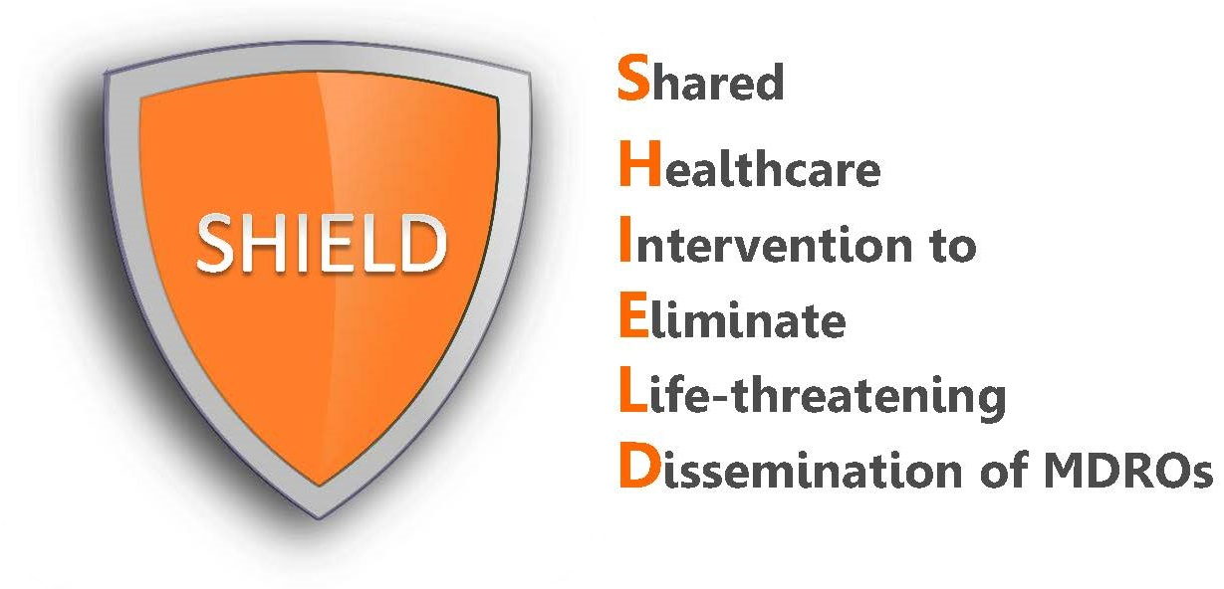

What to Expect

What is SHIELD?
SHIELD (Shared Healthcare Intervention to Eliminate Life-threatening Dissemination of MDROs) is a decolonization quality improvement program for hospitals to reduce MDRO spread and infections.

SHIELD was initially a regional demonstration project in 38 healthcare facilities (18 hospitals, 17 nursing homes and 3 long term acute care hospitals (LTACHs)) in Orange County, California. The intervention resulted in substantial reductions in MDROs in participating facilities and county-wide. Because of this success, the protocols and training materials are being made available here in editable and pdf formats.

Why adopt the SHIELD program?
The SHIELD intervention is right for you if:
- Your facility is experiencing cultures or infections due to MDROs
- Your facility is worried about MDROs in general
- Your facility is willing to do a campaign to reduce MDROs
- Your facility is interested in the benefits of “decolonization” but needs “how to” help

The SHIELD program is effective against the following organisms:
- CRE: Carbapenem-Resistant Enterobacteriaceae
- MRSA: Methicillin Resistant Staphylococcus aureus
- VRE: Vancomycin-Resistant Enterococcus
- ESBL: Extended Spectrum Beta-Lactamase Producers

What is the decolonization intervention?
In the SHIELD program, decolonization refers to the use of topical products to reduce bacteria on the body that can produce harmful infections. For hospitals, this includes:
- Chlorhexidine (CHG) bathing on admission and for routine bathing or showering of all adult patients on contact precautions. This involves 2% leave-on CHG for bed baths and 4% rinse-off CHG for showers.
- Nasal iodophor (10% povidone iodine) swabs for the nose given twice daily for 5 days on admission to all adult patients on contact precautions.

What are the SHIELD steps for implementation?
The following steps are recommended for a successful implementation. Like many infection prevention programs, it takes time to achieve culture change. Expect that it will take a full quarter to achieve solid adoption after training, feedback, and encouragement.
Step 1: Discuss with hospital leadership to confirm program is for you
Step 2: Use provided materials to present at Nursing and Medical Director meetings and document adoption of the program
Step 3: Purchase product
Step 4: Ensure chlorhexidine (CHG) compatibility of lotions and skin products
Step 5: Create a standing automated admission order for decolonization in patients on contact precautions or arrange daily nursing rounds to find patients on contact precautions
Step 6: Train staff using provided educational materials, handouts, and videos
Step 7: Begin intervention
Step 8: Use skills assessment checklists to check quality of bathing and nasal application and provide feedback to improve process
Step 9: Monitor progress using key outcomes, for example, consider monitoring MDRO cultures, use of contact precautions, HAI infections, antibiotic use, and hospital transfers for infection

How does the SHIELD toolkit help with implementation?
The SHIELD toolkit provides the following in pdf or editable Word documents
- Standardized nursing protocols and step-by-step directions
- Educational materials for training and assessment
- Staff and patient handouts, including 1-page “how to” guides
- Patient communication and FAQs for nursing staff to respond to questions
- Skills assessment checklists
- Brief video links for training for showering or bed bathing

