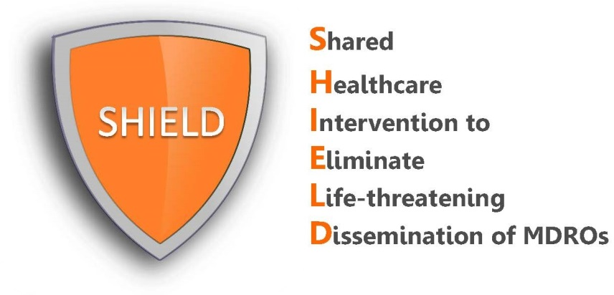

How to Find Eligible Patients:
Instructions for Hospitals

The SHIELD program is designed to be implemented in hospitalized adult patients who are on contact precautions regardless of the reason for isolation. We recommend adopting either of the following strategies in order to find eligible patients:
- Create automated processes to populate admission order sets.
A standing admission order set for decolonization can be created in the electronic medical record software (EPIC, Allscripts, eClinicalWorks, athenahealth, etc.) and can be programmed to be activated when isolation is ordered.
Adult patient admission/readmission

Order contact precautions

Admission order set for decolonization is automatically activated

- Nursing protocol for daily bathing/showering with CHG is activated
- Nursing protocol for 5 days of twice daily nasal iodophor

- Arrange door-to-door daily nursing or nurse manager rounds to locate adult patients on contact precautions.
Nursing staff can arrange daily rounds in order to locate eligible patients according to the appropriate “contact precautions” door sign. Perform checks to ensure decolonization is active on the nursing track list or establish mechanisms for nurses to activate decolonization based on standing protocols.
If not, develop mechanism to activate:
- Nursing protocol for daily bathing/showering with chlorhexidine
- Nursing protocol for nasal iodophor application

Ensure decolonization process in place
Arrange daily nursing/nurse manager rounds
Locate eligible patients according to “contact precautions” door sign

