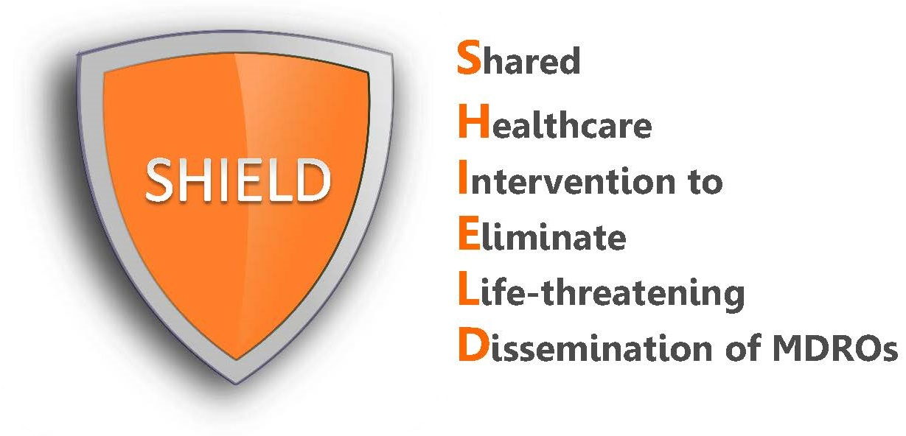

Chlorhexidine (CHG) Compatibility

Is it true that certain soaps should not be used with CHG?
Other soaps should not be used with CHG for two main reasons. First, other soaps are not needed. CHG is a bathing soap and it will clean the skin better than regular soap and water. Second, other soaps can inactive CHG and prevent it from killing germs.

Can lotions and skin products be used with CHG?
Yes, but it is important to check that products used are compatible with CHG so that they do not inactivate CHG and prevent it from killing germs. Contacting the manufacturers of lotions and other skin products can be an easy way of confirming compatibility. If manufacturers are not sure about one product, there are often other similar products that are available and known to be compatible. It is also important that CHG is the first product applied to the skin and allowed to dry. Other compatible lotions and skin products can then be used on top.

What about medicated or wound care skin products and CHG?
If your patient is prescribed a treatment regimen for the skin, used as medically directed and apply CHG for routine bathing. We do not recommend that CHG compatibility be checked for prescribed medications because they are needed. Such products can include steroid creams, anti-fungal creams, anti-itch creams.

What about deodorant, shaving cream, and shampoos?
These products are all incompatible with CHG and should be used sparingly. Shampoos should be used on hair and kept off as much of the body as possible when rinsing.

