Nursing Protocol:
Basin Bed Bathing with 2% Chlorhexidine

Who should receive chlorhexidine?
- All adult patients on contact precautions

Excluded patients
- Known allergy to chlorhexidine (CHG)

Protocol for Basin Bed Bathing with 2% Chlorhexidine
- CHG bed bathing to be provided daily beginning on admission
- Provide one-page CHG information sheet for patients to read prior to initial CHG bed bath. These information sheets do not replace verbal instruction, but they save time and allow reinforcement of information already read.
- Pre-Bath: Clean all incontinence or gross soilage using a CHG compatible baby wipe or cloths with water. Do not use soap which can inactivate CHG. Ensure trash can nearby.
- Educate the patient that the CHG bed baths work better than soap and water in removing bacteria from the skin and that wipes soaked with CHG serve as their protective bath.
- If the patient wishes to self bathe, provide verbal instructions, and assist with hard to reach areas. Self-bathers will need assistance with cleansing of any wounds and devices.

What will you need:

- One 4 oz bottle of 4% Liquid CHG to be diluted
- Bath basin
- 6 disposable wipes (more if needed for lines, tubes, drains or larger patients)
How to create 2% chlorhexidine
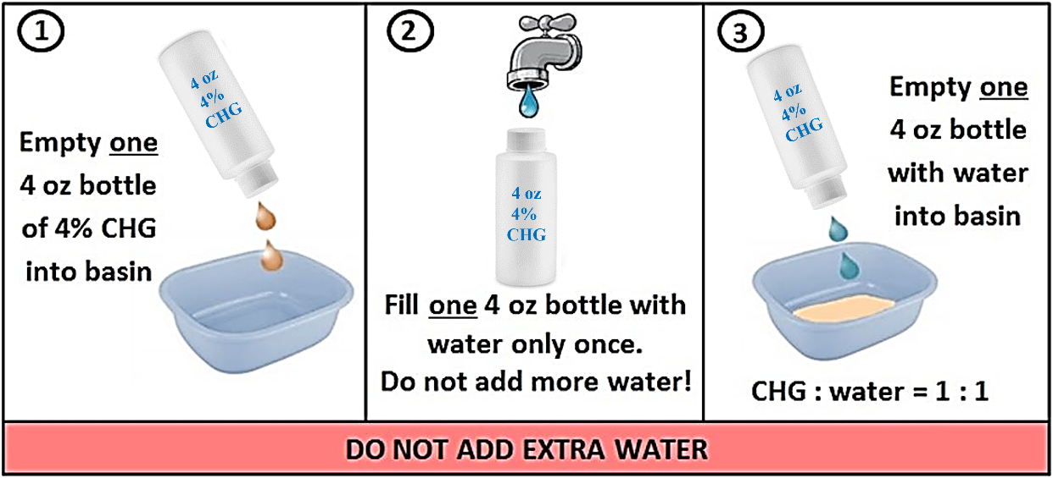
How to Perform a No-Rinse Bed Bath with 2% Chlorhexidine:
- Obtain a bath basin and dispense one 4 oz bottle of 4% CHG liquid into basin.
- Fill one emptied 4 oz bottle with water and dispense it into basin with 4% CHG liquid in it. Do not overdilute. Use only equal part of water to CHG. Goal is to achieve 2% CHG.
- Bring basin to bedside. Soak disposable wipes in basin. Wring each disposable wipe prior to application. Only soak and wring each disposable wipe once. DO NOT apply wipe to patient and place back in basin to rinse and apply again. Be sure to firmly massage CHG onto the body to clean the following body areas.
  - Wipe 1: Face, neck, and shoulders. Avoid getting CHG into eyes and ears. Flush eyes with water if contact.
  - Wipe 2: Chest, arms, and hands
  - Wipe 3: Abdomen, sides (flank) and then groin/perineum
  - Wipe 4: Right leg and foot
  - Wipe 5: Left leg and foot
  - Wipe 6: Back of neck, back and then buttocks
  - Use additional wipes for larger patients and/or cleaning 6 inches of all devices including central lines, urinary catheters, drains, G-tube/J-tubes, rectal tubes, chest tubes.
  - Wipe over non-gauze dressings. This will help remove bacteria where devices penetrate the skin. CHG is safe on devices and can be used over occlusive and semi-occlusive dressings.
  - Allow to dry naturally. Do not wipe off.
  - Do not place wipes with 2% CHG directly on bedding as contact with bleach during the washing process can leave brown stain. Once CHG is applied to the skin, it binds skin proteins and will not rub off onto bedding.
  - Dispose wipes in trash. Do not flush in commode.
  - If a moisturizer or lotion is needed, only use lotions that are compatible with CHG.
  - CHG can be used as a shampoo. If using other shampoo products, be sure to keep shampoo off the rest of the body since it can prevent CHG from working to kill germs.
  - Post-Bath
    - Incontinence episodes: Remove soiled incontinence using CHG-compatible baby wipes, disposable cloths, or towels. If necessary, rinse off the affected area with water. Then, reapply 2% CHG using a disposable wipe. Allow to dry naturally.
    - If barrier protection is needed, be sure to use CHG-compatible barrier protection products.

IMPORTANT REMINDERS for CHG Cloth Bathing
- Do not use regular soap with CHG. Many soaps inactivate chlorhexidine. CHG works better than soap and water in deeply cleansing the skin.
- Ensure thorough cleaning, with special attention to commonly soiled areas such as the neck, skin folds, and perineal areas. CHG is safe to use on perineal areas, including external mucosa.
- For candidal rashes, note that CHG is active against candida. However, be sure that the CHG is dry between body folds. Fan the area with the blue insulator to aid drying. If not completely dry, rashes may worsen.
- CHG is safe for superficial wounds, including stage 1 and 2 decubitus ulcers, superficial burns, as well as rashes and abrasions. These areas are at high risk for infection and CHG kills germs and helps prevent infections. Do not use on large or deep wounds, (e.g. packed wounds).
- Use CHG for all bathing purposes, including full-body bathing, cleaning after incontinence clean up, or any other reasons for additional cleaning. This includes the face; however avoid contact with eyes and ears.
- If moisturizer is needed, provide patient with CHG-compatible lotion.
- Allergic reactions are rare, but can occur. If a patient experiences a reaction possibly related to CHG product, contact the patient’s treating physician for all clinical decisions on whether to stop the product or provide any medication to address a possible reaction.
- Maintain facility policies for covering devices, including dressings to prevent water penetration and introduction of water borne bacteria.

