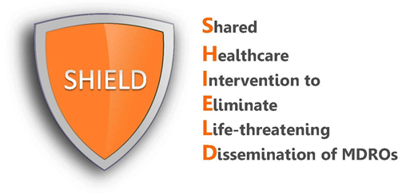

Frequently Asked Questions
for Hospitals

What is SHIELD?
SHIELD (Shared Healthcare Intervention to Eliminate Life-threatening Dissemination of MDROs) is a decolonization program for hospitals to reduce MDRO spread and infections. Most hospitals are performing decolonization (daily chlorhexidine bathing with or without nasal decolonization) in their ICUs. The SHIELD program adds decolonization to all patients on contact precautions, regardless of the reason for contact precautions.

SHIELD was initially a regional demonstration project in 38 healthcare facilities (18 hospitals, 17 nursing homes and 3 LTACHs) in Orange County, California. The intervention resulted in substantial reductions in MDROs in participating facilities and county-wide. Because of this success, the protocols and training materials are being made available here in editable and pdf formats.

The SHIELD program is effective against the following organisms:
- MRSA: Methicillin Resistant Staphylococcus aureus
- VRE: Vancomycin-Resistant Enterococcus
- ESBL: Extended Spectrum Beta-Lactamase Producers
- CRE: Carbapenem-Resistant Enterobacteriaceae

What is the decolonization intervention?
In the SHIELD program, decolonization refers to the use of topical products to reduce bacteria on the body that can produce harmful infections. For hospitals, this includes:
- Chlorhexidine (CHG) for routine daily bathing or showering of all adult patients on contact precautions. This involves 2% leave-on CHG for bed baths and 4% rinse-off CHG for showers.
- Nasal iodophor (10% povidone iodine) swabs for the nose given twice daily for 5 days starting on admission for all adult patients on contact precautions. According to the hospital’s preference, iodophor can be substituted with mupirocin.

How do I use the products and how often?
See nursing protocols for detailed directions on how to bathe with chlorhexidine and apply the nasal iodophor.

Why do we apply decolonization to patients on contact precautions even if they are not on contact precautions due to an antibiotic resistant organism?
There are two main reasons for this. First, a contact precaution sign on the door or flag in the chart is an easy way for nursing to target high risk patients for the decolonization protocol. Second, in general, patients on contact precautions are more likely to have resistant organisms. For example, patients with C. difficile generally have been exposed to antibiotics, and antibiotic exposure is a major risk factor for antibiotic resistant bacteria. Also, patients with one antibiotic resistant organism are known to be more likely to have another.

What if our hospital does not use contact precautions?
If your hospital does not use contact precautions and you would like to participate in the SHIELD program, you can use any flag or tracking mechanism for patients with a multidrug-resistant organism to target them for decolonization.

