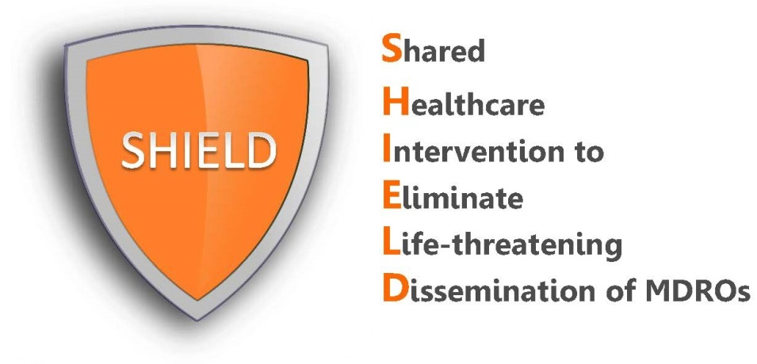

Patient Talking Points
Chlorhexidine Bathing

Patients may have questions regarding CHG bathing. Below are some suggested responses to common patient questions.

REMEMBER: Your enthusiasm and encouragement will be the greatest predictor of a patient’s acceptance and support for the protocol.

What are these cloths for?
“This is your protective bath while you are staying at this hospital. All patients on contact precautions here are provided this bath to prevent infection. This type of bathing uses a special soap called chlorhexidine which is deeply cleansing and works better than regular soap and water to remove germs and protect you from infection. It has been used on millions of patients in many hospitals and some nursing homes across the country to clean the skin and protect from germs.”

How do you know it works better than soap?
“We are using the chlorhexidine soap because it has been proven to get rid of body germs and prevent infections in large clinical trials in U.S. hospitals. In those studies, antibiotic-resistant bacteria dropped by almost 40% and bloodstream infections dropped by 50%.”

I don’t feel as clean after bathing with the cloths.
“I know we usually think of baths as having soapy water, but while you still require medical care at this hospital, these cloth baths work better than soap and water to remove germs from the skin. It is deeply cleansing and will protect you more than soap and water.”

Why do these cloths leave my skin feeling sticky?
“The sticky feeling is temporary and is due to aloe vera in the cloths which moisturizes your skin while it cleans, so it’s actually a good thing. The aloe causes the sticky feeling that goes away after a few minutes and leaves your skin soft and moisturized.”

Can I use my own soap and/or lotions along with this bath?
“No, other soaps and lotions may prevent this bath from working and may not protect you because they interfere with the germ-fighting ingredient in the soap. This bath works better than soap and water to protect you, so it is important that you only use the soap we give you during your stay.”

I would prefer to use my own shampoo and face soap. Is this okay?
“Other soaps and shampoos may interfere with the CHG soap which works the best to remove germs from your body. We strongly encourage you to use the CHG while you are here. However, if you must use you your own shampoo or face soap, please use them first and try to keep the shampoo and face wash off of the body so CHG will work as body soap.”

I am too tired and I don’t feel like bathing.
“I understand you must be tired, but this bath is important to protect you from bacteria and germs. It will only take 5 to 10 minutes and will make you feel refreshed. I will help you. If you are too tired right now, I can come back later and check in with you.”

I don’t think I can bathe because I have an IV.
“Don’t worry, we do this all the time. In fact, because you have lines, it’s even more important to keep germs off the skin and prevent infection. We actually clean the lines after we clean your skin. I will help you with areas around the lines and any other hard to reach areas.”

Can I wait to bathe tomorrow? I just arrived today.
“Your first day in the unit is the most important day to take a bath and protect you from germs before we begin your medical care here. Bathing takes only 5-10 minutes and will make you feel refreshed and clean.”

I would prefer to perform my own bed bath.
“If you wish to bathe yourself, let me give you important instructions and a handout (“CHG Bathing for Patients”). Remember to read the instructions carefully, as the bath may not protect you if it is not done correctly. The CHG cloths have a special no-rinse soap that works better than soap and water to remove germs that can cause infection. Massage the skin well with the cloths to remove skin germs. Don’t rinse since the CHG continues to work for 24 hours to keep germs away. Don’t forget to clean all skin areas, including the neck and skin folds. Most patients need some help. I can help you with any hard to reach areas as well as help you clean on and around your lines or drains.”

Can I use the soap on wounds or skin rashes?
“Yes. In fact, cleaning skin wounds and rashes is particularly important since germs can get under the skin when there is a skin break. You should also use the cloth over plastic dressings and to clean 6 inches of any line, tube, or drain closest to your body. I will help you with that part of your bath.”

The label for liquid CHG says it can be used for routine bathing (skin, wound, and general skin cleansing), but CHG cloths are labeled as preoperative. Is it okay to use the cloths for routine bathing?
“Yes, both CHG liquid and CHG cloths are safe to use for routine bathing. The cloths are labeled based upon the original studies performed by the manufacturer to market the product. Since then, many large clinical trials have now shown that routine CHG bathing reduces serious infections, even in critically ill patients. The manufacturer came to this hospital to help train the staff on use of this product for routine bathing based upon these trials. In fact, 80% of US hospitals now use CHG as their soap for routine bathing of ICU patients. This type of routine bath has been used in millions of patients and is well-tolerated and safe. Our goal is to prevent infection and protect you while you are here.”

