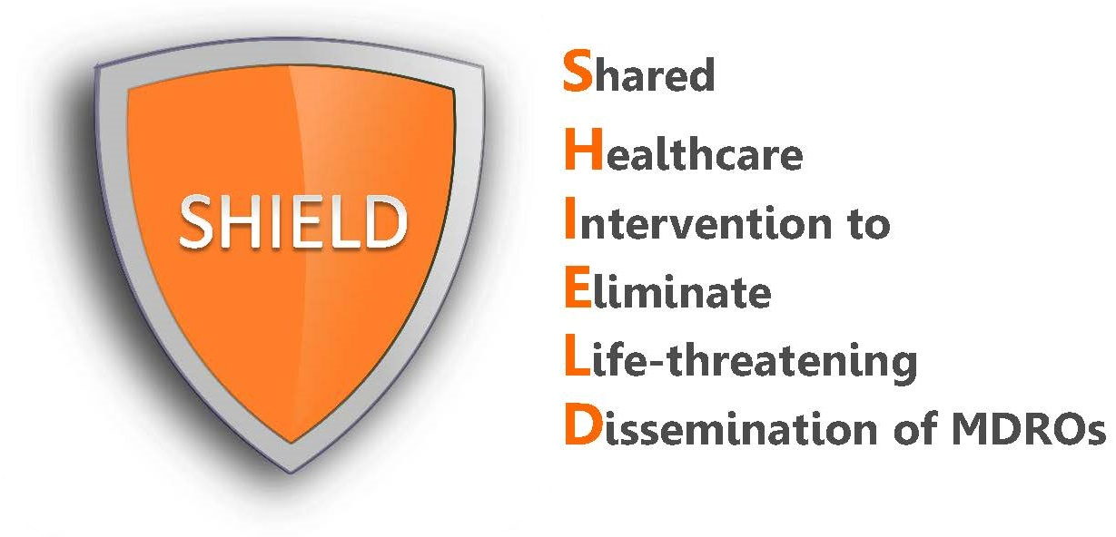
SHIELD Products

What decolonization products are used in the SHIELD program?
The SHIELD program uses FDA cleared skin and nose antiseptic products to help remove germs from the surface of the body to prevent infection. These products are:
- 2% chlorhexidine (CHG) no-rinse cloths for bed bathing
(note: alternate instructions provided for 2% no-rinse CHG basin bed baths)
- 4% liquid CHG for showering with mesh sponge
- 10% povidone-iodine (iodophor) swabsticks for the nose

The following pictures show the products* used for the California SHIELD Orange County demonstration project. Similar products can be substituted.


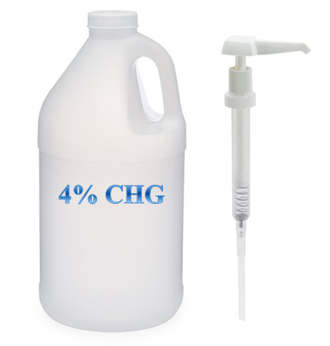
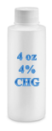
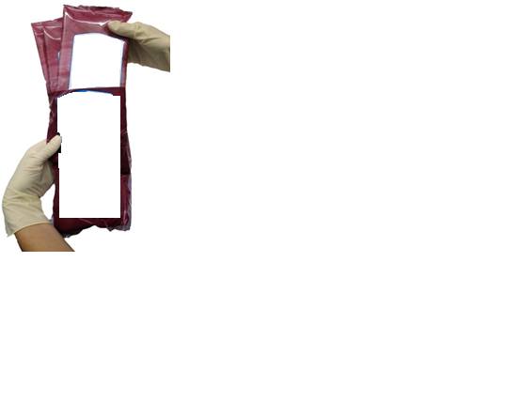
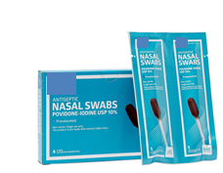

*The use of trade names is for identification only and does not imply endorsement by the Department of Health and Human Services or the Centers for Disease Control and Prevention.
Who should receive these products?
The SHIELD program is for all patients. This means that the usual soap for showering and bed bathing is replaced with CHG and the iodophor nasal products are given to all patients unless they choose to refuse. This quality improvement program would means that these products become the normal standard of care in the long-term acute care hospital (LTACH). The tools and forms supplied in this toolkit are intended to help with adoption.

How often should these products be applied?
The best time to remove germs from the skin is on admission to the LTACH. The SHIELD program involves chlorhexidine (CHG) bathing on admission and for routine bathing or showering. In addition, nasal iodophor (povidone iodine) will be given twice daily for 5 days on admission and then twice daily for 5 days according to the hospital’s every other week schedule until discharge for all patients. If a patient is readmitted, the decolonization protocol begins anew.

How safe are the products?
Chlorhexidine and povidone iodine have been used in healthcare for over 60 years and have an excellent safety record. In fact, chlorhexidine and povidone iodine are both sold over-the-counter in local drug stores. All products used for decolonization, including CHG bathing liquid and cloths and nasal iodophor, are topical for use on skin and in the nose.

Although allergic reactions to CHG are rare, they can occur. When reactions occur, most of them are limited to the site of application and include skin irritation, rash or redness. These uncommon side effects resolve with discontinuation. For nasal iodophor, side effects are uncommon, mild and resolve with discontinuation. They may include nasal irritation, runny nose, and sneezing. As with any product, rare serious allergic reactions can occur.

