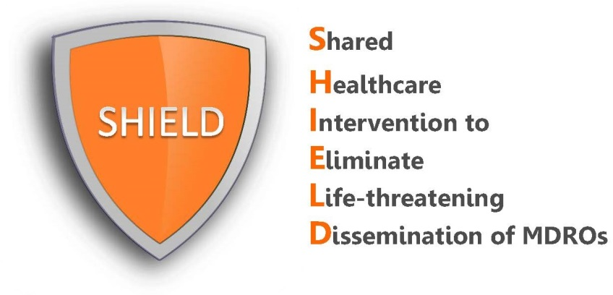

Nursing Protocol
Nasal Antiseptic (10% Povidone-Iodine)
Who should receive iodophor?
- Adult patients in long-term acute care hospitals (LTACHs)
- Use on admission twice daily for 5 days and then twice daily for 5 days according to the LTACH’s every other week schedule until discharge
- Do not use if the patient has an allergy to iodine
- If a patient is readmitted to the LTACH, the protocol starts again, including the admission treatment

Excluded patients
- Known allergy to iodophor or iodine

Protocol for Using Iodophor
- Place patient’s bed at 30 degrees, if tolerated.
- Have patient use a tissue to blow their nose or clean the nares and tip of nostril. Discard tissue.
- Insert swab into one nostril and rotate for 30 seconds covering all surfaces. Apply in a circular manner to entire surface of inner nose at least 3 times. Discard swab.
- Using the second swab, repeat step 3 in the other nostril (swab 2).
- Do not blow nose. If solution drips, dab with tissue.
- Do this twice a day for 5 days on admission, and then repeat every other week.

Special Circumstances
- If nasal devices are in place (e.g. nasal intubation, NG tubes), swab iodophor around tubing, if possible.
- If nasal packing is in place (e.g. recent surgery/trauma), do not apply to that nostril.
Missed Doses
If one dose is missed, restart iodophor as soon as possible and go back to the regular schedule. Do not double up doses. If more than 1 day’s worth of iodophor is missed, the patient will need to restart the 5 days of therapy.
Adverse Events
Allergic reactions are rare, but can occur. If the patient experiences a reaction possibly related to the product, contact the patient’s treating physician for all clinical decisions on whether to stop the product or provide any medication to address a possible reaction.

