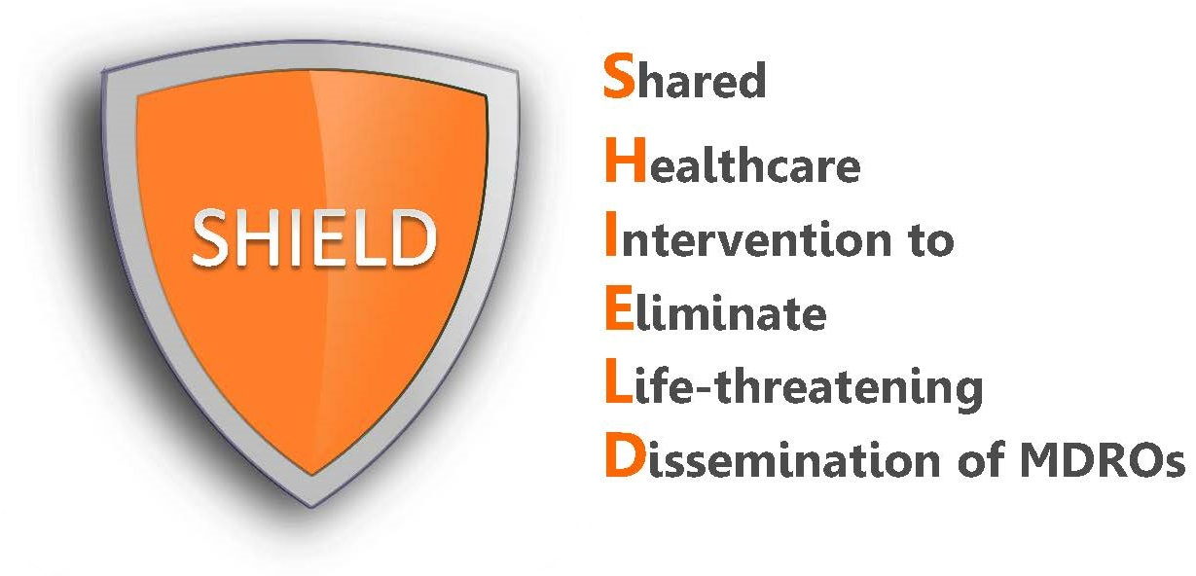
Frequently Asked Questions
Chlorhexidine for Bathing

What is chlorhexidine (CHG) and how safe is it?
CHG is an over-the-counter antiseptic agent that helps to reduce the amount of germs on your skin, including antibiotic-resistant germs such as MRSA. CHG is FDA cleared for this purpose. CHG has an excellent safety profile and has been used in healthcare for over 60 years. Although allergic reactions to CHG are rare, they can occur. Most of them are limited to the site of application and include skin irritation, rash or redness, which resolves with discontinuation.

What if my patient refuses a bath?
Patients have the right to refuse any medical care. Staff need to assess whether the patient is refusing at this time (e.g. tired, in pain, irritable), or whether the patient is refusing all together and if the patient understands the reason and the value of the protective bath (e.g. to prevent infection due to MRSA and other bacteria). Of course, the patient does not wish to have this done, it is their right to refuse.

If the staff member believes that the patient is stating that it’s not the best time, then the staff should offer and encourage a bath at a later time. Remind the patient that the bath is short and only takes 5-10 minutes and the bath will protect them from germs.

Some of the patients can perform their own bath or shower. What should be used, and can the patient bathe themselves?
If the patient wishes to self bathe, provide the patient with the 1-page “Shower with CHG Soap” or “Bathe with CHG Cloths” patient handouts. Having the patient read the instructions will save you time later because the patient will become familiar with the bathing process. Then, prior to bathing, verbally repeat the cloth bathing or showering instructions to ensure proper application. Remind the patient that if the bathing is not performed correctly, they may not receive the protective benefits.

If the patient wishes to perform a bed bath, remember to show the patient how to open the packages since they are difficult to open from the ends. Remind them to massage the CHG onto their skin and over non-absorbent dressings. Help them to clean hard to reach areas and to clean the 6 inches of any tube, drain, or line closest to the body. If the patient is able to step into the shower, 4% CHG liquid soap along with a mesh sponge or non-cotton cloth for application should be provided. Do not use cotton cloths – cotton binds CHG and does not release CHG well onto the skin. Again, help them clean hard to reach areas and parts of tubes, drains, and lines nearest the body.

What if my patient would like to use their own shampoo, conditioner, or face wash?
Remind the patient that regular soap and shampoo can inactivate CHG and prevent it from working. If your patient insists on using their own shampoo or face wash, instruct them to use these first and try to keep the shampoo and face wash off the body so CHG will work as body soap.

Is it okay for my patients to shave and use deodorant?
Even though shaving cream and deodorant may inactive CHG, we understand that patients will want to shave and use deodorant. If shaving is performed, ensure that shaving cream only contacts body area that is being shaved.
What if my patient has an incontinence episode or needs freshening up throughout the day?
CHG cloths should be used for all bathing purposes, including full-body bathing, cleaning after soiling, or any other reasons for additional cleaning such as freshening up. Do not use soap to cleanse incontinent patients because soap can inactivate CHG. First remove urine/stool with usual incontinence wipes or cloths and water. Next, clean with CHG and allow to air dry. Finally, apply CHG compatible barrier protection over the area. Repeat as often as needed throughout the day.

My patient reports that their skin feels sticky after the bath.
The sticky feeling is due to the moisturizing ingredients in the CHG cloths and it will go away as it dries. The cloths contain aloe vera.

Is it safe to use on the perineum?
Yes, CHG is safe to use on the perineum, vaginal and external mucosa.
Is CHG safe to use on lines, tubes, and drains?
Yes, it is very important to clean lines, tubes, and drains in addition to the skin surrounding these devices in order to prevent infection. The 6 inches of any tube, drain, or line nearest the body should be cleaned. Non-absorbable (non-gauze) dressings should also be wiped over with the CHG cloth after the skin is cleaned.

Should gloves be worn or changed during bathing with CHG cloths?
Yes. Although it is safe to handle the CHG cloths with bare skin, gloves should be worn for bathing patients. If gloves become soiled, they should be changed.

I am having trouble with applying bandages after bathing my patients with CHG. Does CHG weaken bandage adhesive?
If you are having trouble reapplying a bandage after bathing a patient with CHG, it’s usually because not enough time has elapsed to allow for drying. After bathing a patient, please allow the CHG to dry for about 5 minutes. This should provide ample time for the CHG to absorb and not affect the bandage adhesive. If you cannot wait the full 5 minutes and if the patient’s skin still feels tacky, it will prevent the bandage from sticking properly.
Are there special instructions for large or obese patients?
In order to be effective in removing germs, it is important that CHG cloths are applied with a firm massage on all skin areas (gently massaged onto wounds). This is particularly important in skin folds of large or obese patients since dirt, sweat, and germs can accumulate there. Make sure that after the CHG cloth is applied, the skin fold areas are allowed to fully dry. Lift skin folds to clean by firmly massaging the entire skin with the CHG cloth. Sometimes placing rolled towels to prop open skin folds may help with the application or drying process. Use as many CHG cloths as necessary.

What are the most commonly missed bathing practices that we can enforce with our staff?
- Cleaning lines, drains, and tubes closest to the body as well as cleaning over non-absorbable dressings
- Ensure cloths are applied to skin with firm massage
- Use the CHG wipes on superficial wounds/stage 1 & 2 decubitus ulcers

How should we dispose of the CHG cloths?
Used CHG cloths should be disposed of in the trash. The CHG cloths will clog the pipes. Do not flush. Instruct patients NOT to place the wipes in the commode or toilet.

Will long-term use of CHG cloths cause bacteria to become resistant?
Thus far, despite wide use, CHG resistance has rarely been reported in the U.S.

I think my patient may be having a reaction to the CHG cloths or CHG liquid soap. What should I do?
Similar to all quality improvement programs, any questions regarding issues related to the decolonization products should be directed to the patient’s nurses and treating physicians. An optional tracking form is provided if you would like to track side effects. Severe allergic reactions to CHG are extremely rare. However, if you think a patient may be developing a severe allergic reaction (including hives, severe itching, difficulty breathing, tightness in the chest, swelling of the mouth, face, lips, or tongue), stop the decolonization drug and immediately call 911.

