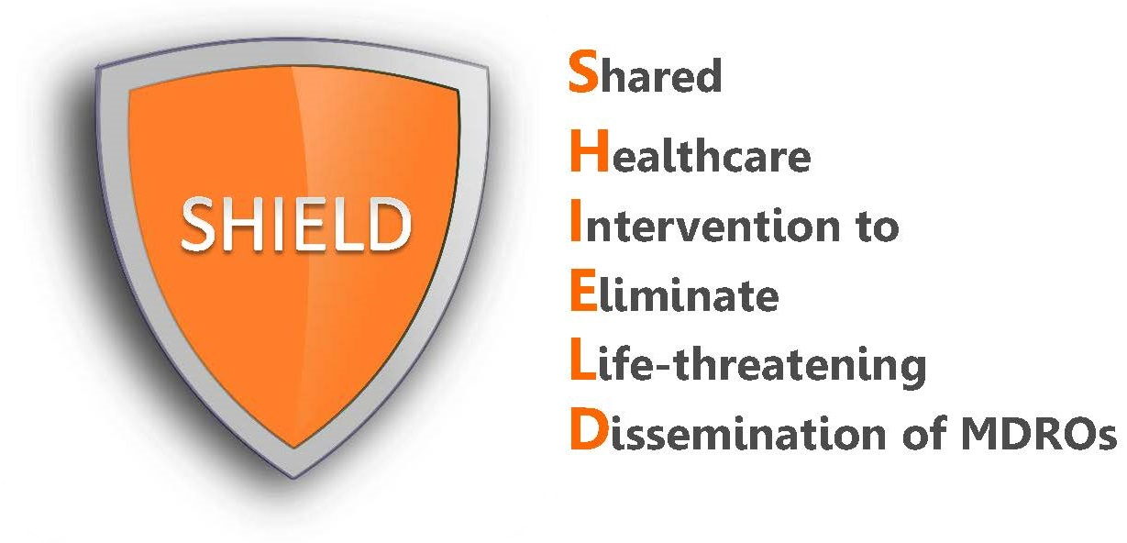

Frequently Asked Questions
for Long-Term Acute Care Hospitals

What is SHIELD?
SHIELD (Shared Healthcare Intervention to Eliminate Life-threatening Dissemination of MDROs) is a decolonization program for hospitals to reduce MDRO spread and infections. Most hospitals are performing decolonization (daily chlorhexidine bathing with or without nasal decolonization) in their ICUs. The SHIELD program adds decolonization to all patients on contact precautions, regardless of the reason for contact precautions.

SHIELD was initially a regional demonstration project in 38 healthcare facilities (18 hospitals, 17 nursing homes and 3 LTACHs) in Orange County, California. The intervention resulted in substantial reductions in MDROs in participating facilities and county-wide. Because of this success, the protocols and training materials are being made available here in editable and pdf formats.

The SHIELD program is effective against the following organisms:
- MRSA: Methicillin Resistant Staphylococcus aureus
- VRE: Vancomycin-Resistant Enterococcus
- ESBL: Extended Spectrum Beta-Lactamase Producers
- CRE: Carbapenem-Resistant Enterobacteriaceae

What is the decolonization intervention?
In the SHIELD program, decolonization refers to the use of topical products to reduce bacteria on the body that can produce harmful infections. For hospitals, this includes:
- Chlorhexidine (CHG) for routine daily bathing or showering of all adult patients on contact precautions. This involves 2% leave-on CHG for bed baths and 4% rinse-off CHG for showers.
- Nasal iodophor (10% povidone iodine) swabs for the nose given twice daily for 5 days starting on admission for all adult patients on contact precautions. According to the hospital’s preference, iodophor can be substituted with mupirocin.

How do I use the products and how often?
See nursing protocols for detailed directions on how to bathe with chlorhexidine and apply the nasal iodophor.

