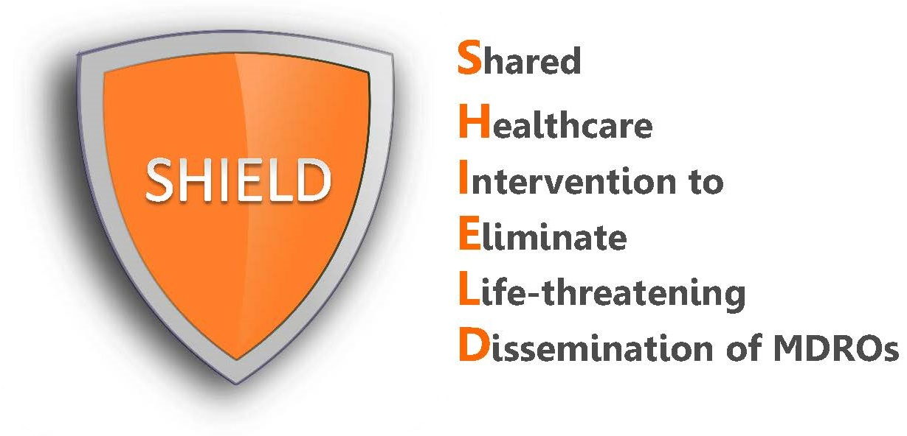

Frequently Asked Questions
Nasal Iodophor

What is iodophor and how safe is it?
Iodophor is another name for “povidone-iodine,” which is an over-the-counter antiseptic that is most known for its use in cleaning scrapes, cuts, and wounds and preventing infections. It is also FDA cleared for use in the nose. Povidone-iodine is an over-the-counter antiseptic product. It has been used in healthcare for over 60 years. Nasal iodophor has been used in thousands and thousands of patients prior to surgery, in ICUs, and in nursing homes as a way to prevent MRSA and methicillin-sensitive Staphylococcus aureus (MSSA) infection. Side effects from iodophor are uncommon, mild and resolve with discontinuation. They may include nasal irritation, runny nose, and sneezing. As with any product, rare serious allergic reactions can occur.

What is the purpose of putting it in the nose?
Iodophor removes germs that commonly live in the nose, including methicillin-resistant Staphylococcus aureus, or MRSA. MRSA is known to cause thousands of invasive infections in the United States annually. Many recent studies have shown the effectiveness of decolonization strategy in reducing risk of MRSA and other multidrug-resistant organism infections in hospitalized patients. Because having MRSA in the nose is a known risk factor for later infection, our hospital has decided to adopt the use of iodophor for our patients to prevent transmission and infection.

Is decolonization a proven strategy?
Yes. Use of chlorhexidine baths and nasal decolonization has been proven in large clinical trials to reduce MRSA and other bacteria and prevent infection. This has been shown in hospital ICUs and in long-term acute care settings.

Why are we giving iodophor instead of mupirocin?
Iodophor has many advantages over mupirocin. First, it is an antiseptic product, not an antibiotic. Second, there is evidence that it is better tolerated than mupirocin. Third, mupirocin resistance has been reported throughout the U.S. and is common in hospitals.

What if the patient wants to blow their nose after application?
Patients should be told to blow their nose before the application to help clear the nasal area. They should be encouraged not to blow their nose immediately after application for best effects.

Is it okay to provide decolonization if my patient is not alert?
This routine decolonization regimen of chlorhexidine soap plus nasal iodophor can be approved as a standing nursing protocol which is covered in the patient’s admission agreement as usual care. It would be provided with MD order. While patients are able to refuse, all patients who are unable to refuse will be provided this as the facility’s standard of care for patients.

If my patient refused the last iodophor dose, am I supposed to offer it again?
This protective regimen should be encouraged among patients. If a patient refused their medication, staff would try to encourage the patient to take it at a later time. Similarly, if a patient refused a bath, staff would try to encourage a bath at a later time. Staff need to assess whether the patient is refusing at this time (e.g. tired, in pain, irritable), or whether the patient is refusing all further doses and if the patient understands the reason and the value of the iodophor (e.g. to prevent infection due to MRSA and other bacteria).

My patient left our hospital, but has been readmitted. Do they need to receive iodophor again?
Yes. Regardless of prior receipt, iodophor should be administered each time a patient is admitted to your hospital to ensure patients are protected for their entire stay.

What if the patient develops a reaction?
Similar to all quality improvement interventions, if a problem arises, it should be brought to the attention of the treating nurse and physician, who will decide all necessary actions related to discontinuing product and ordering any medications to address the reaction.

