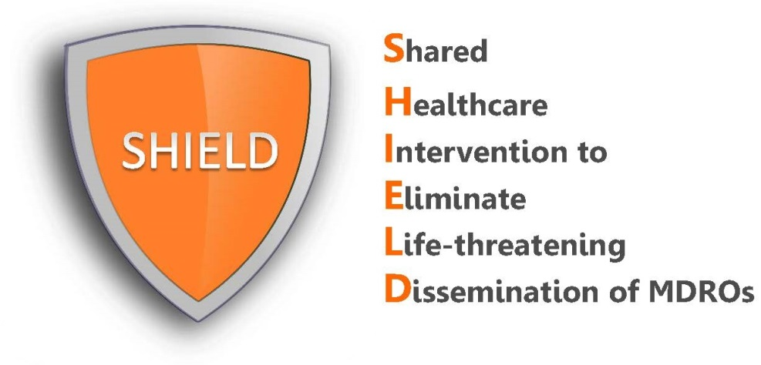

SHIELD Program

ATTENTION: PHYSICIANS AND STAFF

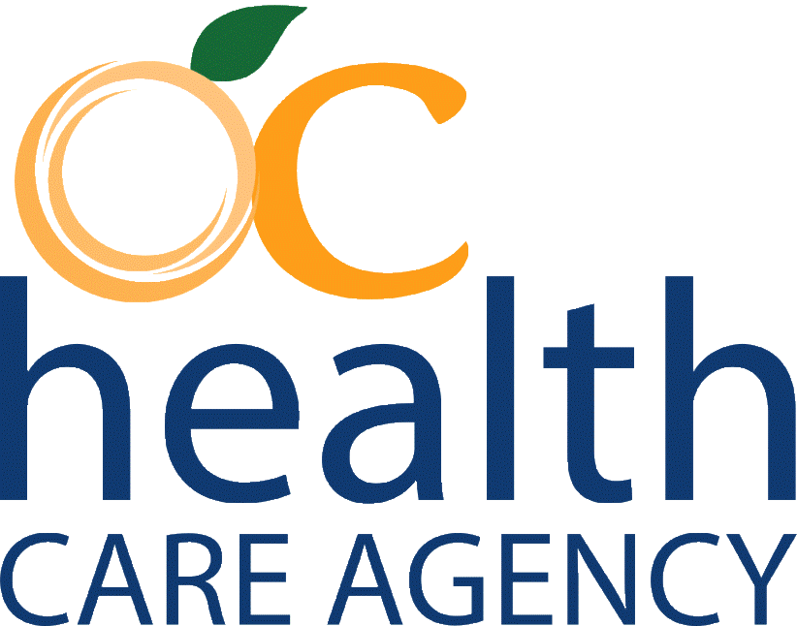
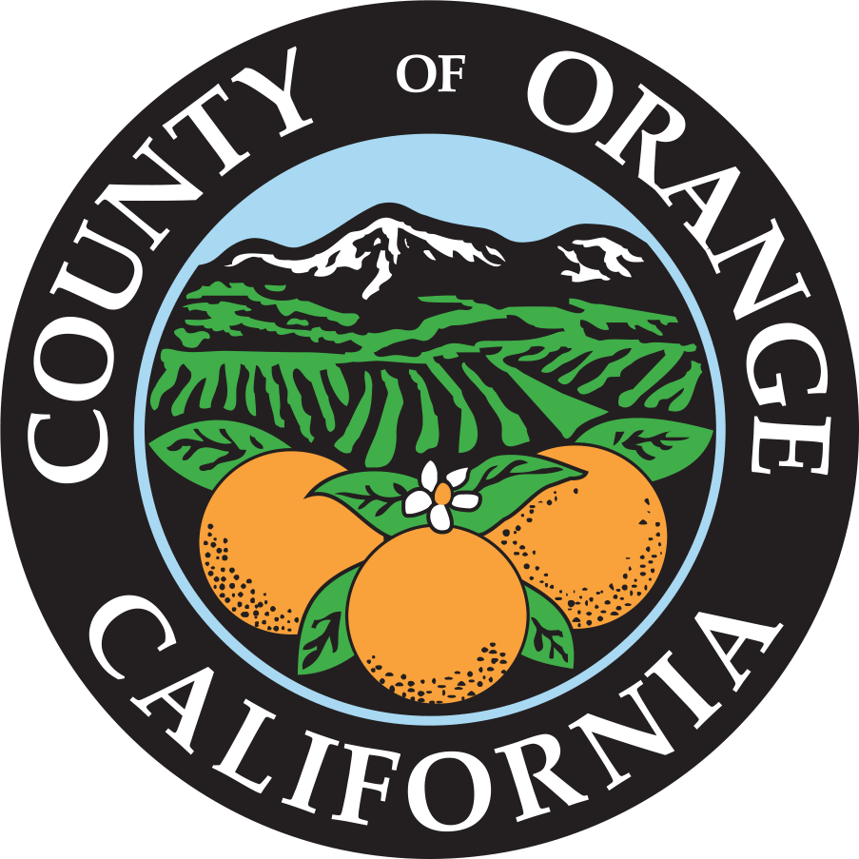
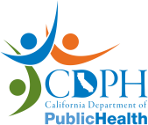
We are pleased to inform you that our long-term acute care hospital (LTACH) is adopting the SHIELD Program to reduce the spread of multidrug-resistant organisms (MDROs) in our LTACHs.

Our facility has adopted a decolonization strategy that includes:
- Chlorhexidine (CHG) for routine bathing and showering of all adult patients
- Twice daily nasal decolonization with 10% povidone-iodine on admission for 5 days and then twice daily Monday-Friday every other week
All treatments used for decolonization, including CHG bathing liquid and cloths and nasal iodophor, have been cleared by the FDA. They are all topical and their safety profile is excellent.
With questions, please contact the SHIELD OC Coordinating Team
(949) 824-7806 or SHIELDOrangeCounty@gmail.com

