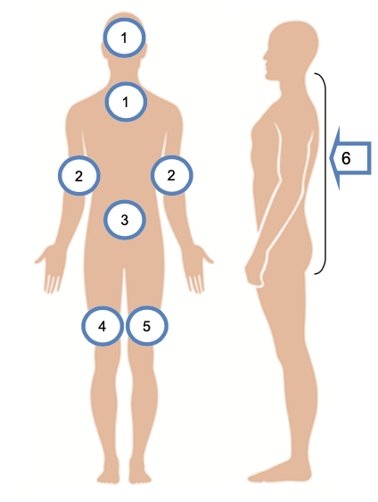

* CHG is short for “chlorhexidine gluconate”
* Wash all body areas shown in the picture
* Avoid eyes and ear canal
* Pay close attention to germ hot spots: neck, groin, skin folds, between fingers and toes
* Ask for help with hard-to-reach areas
* After shower, ask your nurse to clean wounds and devices

**CHG removes germs from the body to prevent infection**

**STEP 1:** Wet entire body and non-cotton wipe/sponge

**STEP 2:** Rub CHG onto the non-cotton wipe/sponge

**STEP 3:** Massage CHG into all skin areas and use as shampoo

**STEP 4:** Leave CHG soap on for 2 minutes

**STEP 5:** Rinse well and towel dry

**Showering with CHG Soap**