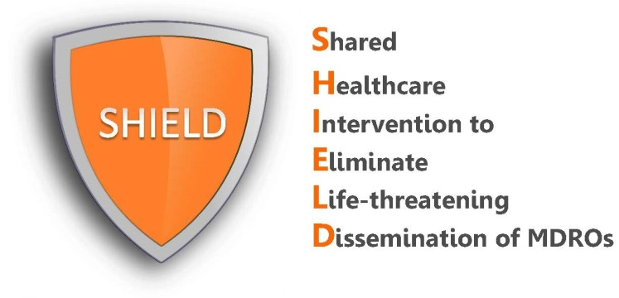

Dear Resident,
We are pleased to inform you that our facility has implemented SHIELD, a nationally recognized quality improvement program to reduce antibiotic-resistant bacteria in hospitals and nursing homes.
Our nursing home uses chlorhexidine bathing soap and povidone-iodine (iodophor) nose ointment for all residents in hopes of reducing the spread of bacteria. Chlorhexidine soap and nasal ointment have already been proven in hospitals to greatly reduce multi-drug resistant pathogens and bloodstream infections in hospitalized patients. These products have been used for skin cleansing in hospitals for decades and are available over the counter at your local drugstore.
The chlorhexidine soap (2% leave-on for bed bath or 4% rinse-off for shower) will be provided for all baths and showers according to our routine schedule or as requested. The 10% nasal iodophor will be provided as a nose swab (large Q-tip) on admission twice a day for five days and that regimen will be repeated every other week for all residents. These protocols are being applied to all residents in our facility to protect you from infection.
Both products are FDA cleared and are extremely safe. If you are allergic to either product, develop any skin or nose irritation, or refuse these products, they will not be used.
If you have questions, concerns, or want any additional information, please talk to your nurse.

