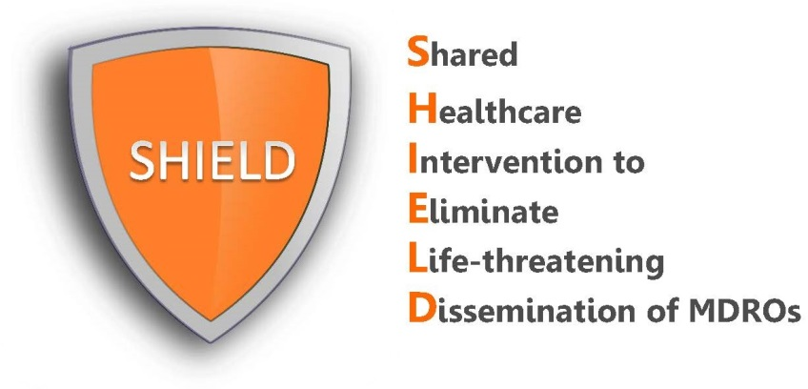

Resident Council/Ombudsman Information Sheet

Our facility will be implementing the Shared Healthcare Intervention to Eliminate Life-Threatening Dissemination of multidrug-resistant organisms (MDROs), a nationally recognized quality improvement program to reduce transmission of multidrug-resistant organisms in healthcare facilities.

What does SHIELD program involve?
In the SHIELD program, we will be implementing a decolonization regimen. Decolonization refers to the use of the following topical products to reduce bacteria on the body that can produce harmful infections.
- Chlorhexidine (CHG) antiseptic soap for routine bathing and showering
- Nasal decolonization with 10% povidone-iodine on admission and every other week

Are the products safe?
Both CHG and iodophor products have excellent safety profiles. They are only used topically. In addition, these FDA cleared products have been used in healthcare for a very long time and are considered safe for use in adults. Both are found over-the-counter, and have been used in healthcare for over 60 years.

Most people have no side effects when using iodophor or CHG. However, as with any medication, side effects may occur. With topically applied products like iodophor and CHG, the most common side effects (occurring in 1-3% of cases) are irritation, rash and redness at the site of application. In extremely rare circumstances, severe allergic reactions to chlorhexidine have been reported. Such serious reactions are so rare that they only occur in case reports. Any potential side effect or allergic reaction believed to be due to CHG or iodophor use will be addressed by resident’s nurse and treating physician.

Who will be participating in the SHIELD program?
We will implement this program as part of quality improvement, and will include to all currently admitted residents in our nursing home.
Is there additional information available for residents and families?
Yes, our nursing home has several informational handouts describing how the products will be used. These handouts will be available to all residents and resident family members. If you have any questions, please also contact your nurse.

