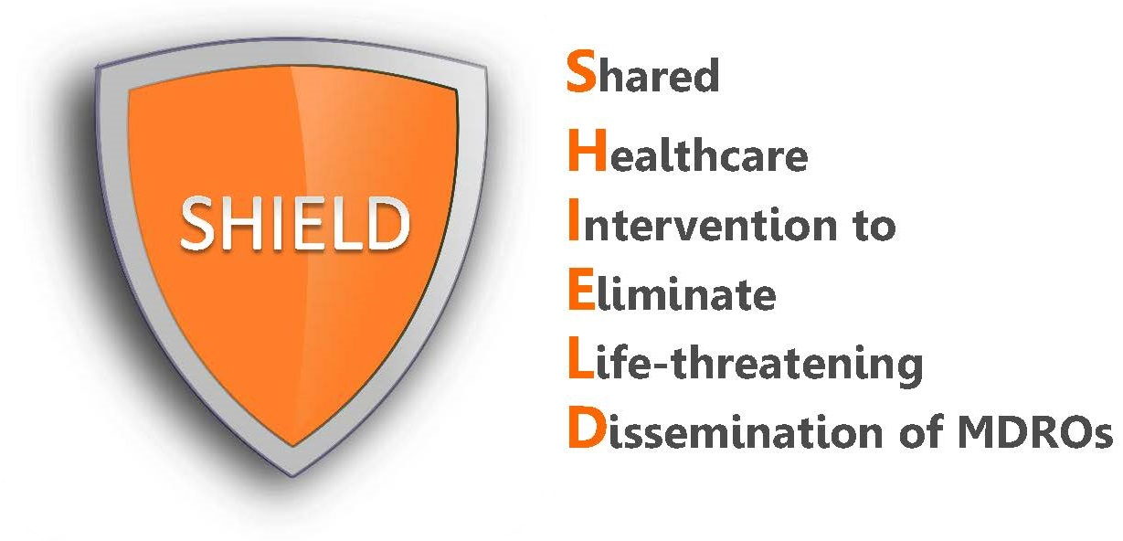

Frequently Asked Questions
for Nursing Homes

What is SHIELD?
SHIELD (Shared Healthcare Intervention to Eliminate Life-threatening Dissemination of MDROs) is a quality assurance and performance improvement (QAPI) decolonization program for nursing homes to reduce MDRO spread and infections.

SHIELD was initially a regional demonstration project in 38 healthcare facilities (18 hospitals, 17 nursing homes and 3 long term acute care hospitals (LTACHs) in Orange County, California. The intervention resulted in substantial reductions in MDROs in participating facilities and county-wide. Because of this success, the protocols and training materials are being made available here in editable and pdf formats.

The SHIELD program is effective against the following organisms:
- CRE: Carbapenem-Resistant Enterobacteriaceae
- MRSA: Methicillin Resistant Staphylococcus aureus
- VRE: Vancomycin-Resistant Enterococcus
- ESBL: Extended Spectrum Beta-Lactamase Producers

What is the decolonization intervention?
In the SHIELD program, decolonization refers to the use of topical products to reduce bacteria on the body that can produce harmful infections. For nursing homes, this includes:
- Chlorhexidine (CHG) for routine daily bathing or showering. This involves 2% leave-on CHG for bed baths and 4% rinse-off CHG for showers.
- Nasal iodophor (10% povidone iodine) swabs for the nose given twice daily for 5 days starting on admission followed by a schedule of Monday-Friday every other week for all residents.

How do I use the products and how often?
See nursing protocols for detailed directions on how to bathe with chlorhexidine and apply the nasal iodophor.

