This form is for optional tracking of decolonization side effects and is for INTERNAL USE ONLY.
For clinical decisions related to possible decolonization side effects, please contact the treating physician.
Please provide contact information below:

Name of individual Clinical Staff completing this form: _____________________________________________

Section I: General Information
Date of First Symptom Onset: ____/_____/________ Date Symptom Resolved: ____/_____/________

Please fill out one form per decolonization side effect.

Resident Gender: M F Non-Binary

Please choose the option that best describes side effect:

Section II: Iodophor (Povidone-Iodine) Related Side Effects

Please provide a brief description of the nasal iodophor related side effect.
(Leave this section blank if event was not due to nasal iodophor)
_____________________________________________________________________

_____________________________________________________________________

_____________________________________________________________________

Section III: Skin Related Side Effects

Please indicate the CHG product that was used:
Liquid CHG (4%) CHG 2% Cloths

Corrective Action Taken (Check all that apply):
Product Discontinued Topical cream/lotion applied None
Oral/IV Benadryl given Oral/IV steroids given Other (specify below)

_____________________________________________________________________________

Please shade the parts of the body, to scale.

ONLY INDICATE RASHES BELIEVED TO BE RELATED TO A DECOLONIZATION PRODUCT:

FRONT BACK
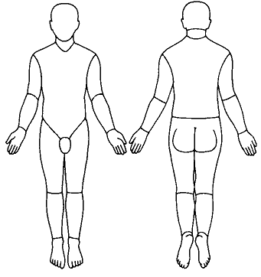
Erythema (Redness) Scaling Blistering
None None None
Mild (spotty or diffuse) Mild, “dry skin” scale Papules only
Moderate, uniform redness Moderate scaling Localized blisters
Intense redness Desquamation/sloughing Extensive blisters or bullae

Is the face involved? Yes No

In your opinion, how certain are you that this side effect is related to a decolonization product?

Definitely related
Possibly related
Unlikely to be related

Is it possible that another medication/product could have produced this reaction?

Yes No

Have any other drug(s) been discontinued?

Yes No
If yes, please specify: ____________________________________________________________________

