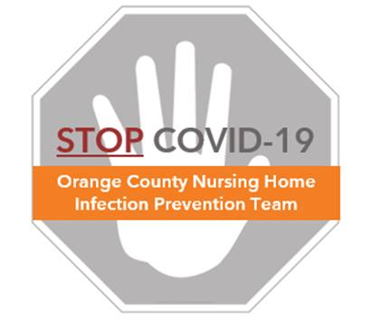

**Monitoring Yourself for Infection Symptoms**

**Frequently Asked Questions (FAQs)**

**Who needs to self-monitor for Novel Coronavirus (COVID-19)?**

* COVID-19 is now widespread in our community and healthcare workers can acquire the virus from the community as well as within the healthcare setting.
* All staff and healthcare workers should be screened upon arrival to the facility for temperature check and query about cold and flu-like symptoms.
* In addition, all staff and healthcare workers should be self-monitoring for signs and symptoms of transmissible infections, including COVID-19**.**
* If you have known contact with a confirmed COVID-19 person, you should be attentive to signs and symptoms of COVID-19 infection (see below) and inform your supervisor immediately if any symptoms develop

**What COVID-19 symptoms should I be monitoring myself for?**

* Monitor yourself throughout the workday. The following symptoms are the most commonly reported:
  + Fever
  + New or change in cough
  + New shortness of breath
* However, the following symptoms may also be present early in the disease before lower respiratory symptoms develop:
  + Muscle aches
  + Unexpected fatigue
  + Other less commonly reported symptoms include: sore throat, headache, diarrhea and nausea which often seem to occur before fever and lower respiratory symptoms
  + Anosmia (loss of smell) and loss of taste have also been identified as symptoms

**What should I do if I develop COVID-19 symptoms?**

* If you are home when symptoms appear, you should:
  + Stay home and contact your healthcare provider immediately
  + Inform your supervisor to arrange coverage and next steps for having you be tested
  + Get plenty of rest, eat and stay hydrated so you can recover. If you live alone, be sure that you have a friend or family member check in on you. For more information see the document *What to Know if You Have Been Diagnosed with COVID-19*.
* If you are at work when you start to notice symptoms:
  + Remain masked. Even if you do not have droplet-producing symptoms such as cough or sneezing, you need a mask to avoid spreading the virus to coworkers or to the environment through your hands.
  + Notify your supervisor to help coordinate for you to go home immediately and to schedule testing for COVID-19 through public health

**I’m not sick, but I’ve been exposed to COVID-19—what should I do?**

* See the *FAQ - Concerns About COVID-19 Exposure* document.

**See Monitoring LOG on next page**

**MONITORING LOG for Coronavirus Disease (COVID-19)**

All employees must monitor themselves carefully for COVID-19 given that there is community spread of this virus and you can become ill at any time. This is even more important if you were not wearing personal protective equipment while caring for a resident with COVID-19 or had known close contact with a family member, friend, or coworker confirmed to have COVID-19. Use the below monitoring log for 14 days from exposure.

|  |  |
| --- | --- |
| Name of Employee: | Contact Number: ( ) |
| Supervisor: | |
| Nature of Exposure Requiring Monitoring | |
| Date of Exposure: ________________________ | |
| List nature of exposure: ________________________ | |
| Name of person you were exposed to: | |
| Your relationship to them: | |

**NOTE**: If temperature is > 99 F or above (or subjective fever), or you develop any of the symptoms listed above, **immediately contact your supervisor.**

|  |  |  |  |  |  |  |  |
| --- | --- | --- | --- | --- | --- | --- | --- |
|  | AM | | |  | PM | | |
| Day | Date & Time | Temperature | List Any Symptoms |  | Date & Time | Temperature | List Any Symptoms |
| 1 |  |  |  |  |  |  |  |
| 2 |  |  |  |  |  |  |  |
| 3 |  |  |  |  |  |  |  |
| 4 |  |  |  |  |  |  |  |
| 5 |  |  |  |  |  |  |  |
| 6 |  |  |  |  |  |  |  |
| 7 |  |  |  |  |  |  |  |
| 8 |  |  |  |  |  |  |  |
| 9 |  |  |  |  |  |  |  |
| 10 |  |  |  |  |  |  |  |
| 11 |  |  |  |  |  |  |  |
| 12 |  |  |  |  |  |  |  |
| 13 |  |  |  |  |  |  |  |
| 14 |  |  |  |  |  |  |  |