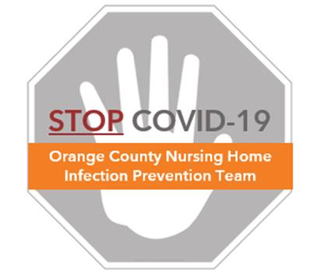

**Preventing COVID-19 in Nursing Homes**

**Visitor Policy**

**Rationale and Guidance**

**Visitors and staff are the most likely sources to introduce COVID-19 into a nursing home**

* To protect residents during this time, the California Department of Public Health recommends a **no visitor policy** and **stopping all resident excursions**, except for urgent medical appointments.
* See the **provided sample letter** for informing residents and families about this policy
* Nursing home staff are essential. Policies are in place for screening all staff for symptoms of COVID-19 prior to entering the facility (see **Staff Screening Protocol**)

**Stay Connected**

* While visitors are not allowed in person, encourage other ways of communication such as **phone calls or video chat** to help residents connect with loved ones
* Set up a system for family members to schedule phone calls and virtual visits. This can be done by establishing a staff member as a point of contact for each resident.

**Exceptions for End-of-Life Circumstances**

* Families may visit residents who are receiving end-of-life care during their last hours
* Visitors for end-of-life circumstances must:
  + Complete a fever check and entry symptom screen. No ill visitors allowed.
  + Wear a mask to enter the facility and be escorted directly to and from the room
* Nurse to instruct **and observe** visitor to:
  + Perform hand hygiene before and after entering room
  + Observe all precautions in place for that patient
* Visitors should be discouraged during an active COVID outbreak, even during end-of-life circumstances. In those settings, if allowed, visitors must adhere to COVID protocols for wearing personal protective equipment.