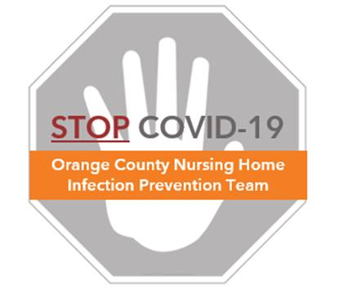

**Staff Safety: Social Distancing, Universal Masking, and Breaks**

**Frequently Asked Questions (FAQs)**

**What is social distancing?**

* Social distancing, also called “physical distancing,” refers to the practice of keeping space between yourself and others to prevent spread of illness between people
* To practice social or physical distancing:



* + Stay 6 feet (about 2 arms’ length) from other people
  + Avoid crowding at nursing stations or break areas
* If 6 feet of distance is not possible at work, keep as much distance as you can and ensure all staff members are masked while working

**Why practice social distancing?**

* Limiting face-to-face contact is one of the best ways to reduce the spread of COVID-19
* According to the Centers for Disease Control and Prevention (CDC), the virus that causes COVID-19 spreads mainly among people who are in close contact (within about 6 feet) for a prolonged period. Close contact generally does not include brief interactions, such as walking past a person. The virus is spread through droplets that are produced when an infected person coughs, sneezes, or talks, and droplets from their mouth or nose are launched into the air and land in the mouths, noses, or eyes of people nearby.
* Since it is possible to spread the virus before you know you are sick, it is important to avoid close contact with other staff, even if you or they don’t have symptoms

**What is universal masking?**

* In keeping with CDC guidance issued in mid-April 2020, every person entering the facility should wear a mask at all times for source control. This is called universal masking.
* Staff should be required to wear a community cloth mask from home (or one provided by the facility) when entering the facility
* Staff whose job duties do not require resident care may wear a clean community cloth mask for source control while at work
* Staff who provide direct care for residents should change from a community cloth mask to a surgical/standard mask when performing residents care duties
* Stay at least 6 feet from others, whenever possible, even when you wear a mask.

**What is the purpose of universal masking?**

* Facemasks are a method of source control, to prevent the spread of germs. All staff should be masked at work, regardless of symptoms.
* Universal masking prevents transmission through coughing, sneezing, talking or singing from someone who is ill
* Universal masking prevents droplets from someone else who is ill from reaching your eyes, nose or mouth
* However, universal masking does NOT replace the need to
  + Keep a 6 foot distance from others whenever possible (social distancing)
  + Clean your hands before and after touching or readjusting your mask
  + Clean your environment in case the person touching items before you was ill

**Masking: who, what, and where?**

* Community cloth masks may be worn during non-resident care activities. Please save disposable surgical/standard masks for direct care providers.
* Do not wear N95 respirators in hallways, nursing stations, or common areas. These are reserved for aerosol generating procedures (eg. CPR, nebulizer treatment, open suctioning)

|  |  |  |
| --- | --- | --- |
| **Who** | **What** | **Where** |
| Non-direct care providers | Community cloth mask | On arriving and leaving work  and continuously through the day |
| Direct care providers | Community cloth mask | On arriving and leaving work  Non-resident care areas  During administrative time (not providing resident care for all or part of day)  During breaks |
| Direct care providers | Surgical/standard mask | Can be worn continuously in resident rooms or during resident care duties |

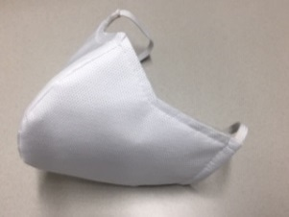 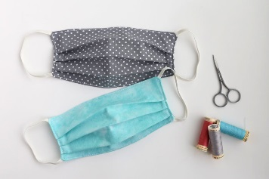 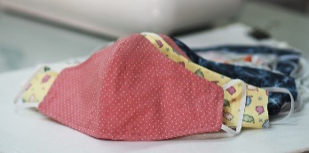

Examples of community cloth masks

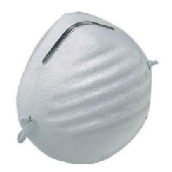

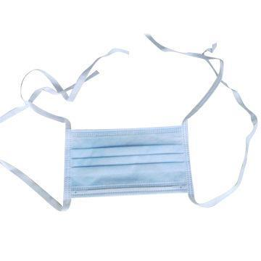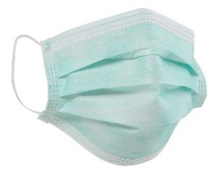

Examples of resident care masks

**I’m not used to wearing a mask all day. What is the safe way to wear a mask?**

* This is new for all of us. The best way to learn how to do it through practice.
* Wearing a mask can cause people to touch their face more due to the need to adjust the mask. **Frequent touching of the mask/face can, unintentionally, increase the likelihood of exposure to COVID-19 if hands are not clean.**
* Here are some key pearls about how to wear a mask. ALL of these take practice.
  + Mask should cover nose and chin
  + Try your best to avoid touching face and mask
  + Clean hands **every time** before & after touching mask
  + Do not put mask under chin, over forehead or over one ear
  + Store mask in clean paper bag or clean, thin, open plastic bag for re-use
  + Put on clean mask if wet, soiled, or damaged
  + For cloth mask, wash mask between use with detergent at home
  + Masks can be re-used unless wet, soiled or damaged.

|  |  |
| --- | --- |
| **DO** | **DON’T** |
| * Wear community cloth mask on arrival to work and when going home * Masks must be worn all day at work, even by non-direct care providers * Cloth masks can be worn in non-resident care areas, during administrative time and breaks by direct care providers * Perform hand hygiene before and after putting on, taking off, or adjusting your mask. * Remove mask by grasping ear loops or ties and directly removing away from face. * Store in a clean, unsealed bag for reuse. * Protect your mask under a face shield when caring for an unmasked resident and anytime when splash or spray could occur * Masks must be professional and not distracting or offensive | * Don’t touch or adjust the mask with unclean hands * Avoid touching the inside of your mask if possible * Don’t remove mask by grasping the front of it * Don’t reuse your mask if it is wet, soiled, damaged, loses function (e.g. unable to breathe through) or the fit cannot be maintained * Don’t wear mask on chin, top of head or hanging over one ear * Don’t double mask * Don’t wear your community cloth mask into resident rooms if you are a direct care provider |

**How do I clean my cloth mask?**

* The novel coronavirus, SARS CoV-2 is easily killed by standard laundry detergent
* It is recommended to bring additional clean cloth masks for backup in case one becomes soiled or wet during the day.

**Will residents and permitted visitors be required to wear a mask?**

* Residents will be asked to wear a mask when leaving their room or when staff enter the room for care, if tolerated
* Visitors are restricted with exceptions for end-of-life circumstances. All visitors must wear masks. We ask for your help in reminding visitors to bring their own mask to preserve the mask supply for staff. If visitors do not bring their own masks, a disposable mask should be provided.

**Are there any health issues I should look out for when wearing a mask all day?**

* Masks are generally safe to use all day
* Because the skin of our faces is more fragile than other parts of our body, there have been reports of staff developing skin irritation from masks. Cloth masks using 100% cotton will minimize this risk while still providing protection for non-direct resident care duties.
* In rare cases, people who wear masks all day can develop side effects that include buildup of carbon dioxide in the air enclosed within the mask. This is least common in cloth masks and is expected to be more common when wearing very tight fitting masks or N95 respirators. The symptoms of carbon dioxide buildup can include tiredness, sleepiness, feeling dizzy, or headache. To avoid this, remove your masks during outdoor breaks when able to be separated by at least 6 feet from another person.

**When am I allowed to take off my mask?**

* To avoid touching and adjusting your mask, it is recommended to leave your mask on at all times, except when needing to remove it for breaks, lunch or when leaving work.
* When alone in a personal office, masks can be removed if not encountering other persons within 6 feet
* Remember to clean your hands immediately before and after taking off and putting on your mask. Store masks in a clean breathable bag (open plastic or paper bag).

**Can I share a meal with coworkers?**

* If you are eating with a coworker, ensure that you are safely distanced (e.g. 6 feet or more) because your masks will be removed to be able to eat. Talking and communicating while socially distanced by at least 6 feet is safe to do even if the mask must be off.

**Is it safe to share food among coworkers?**

* Individually wrapped foods are safe to be shared. If other food is shared, ensure it was not prepared by someone who was ill, and clean your hands before and after handling any shared utensils.
* Always wash hands before preparing or eating food. Do not cook for others when ill.
* When serving food, avoid leaving shared food items uncovered for long periods of time. Shared serving utensils should be cleaned frequently. Wear a mask when serving shared food items.