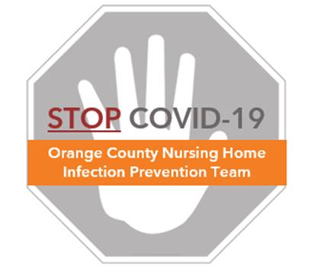

**Guidance for Residents without COVID-19:**

**Social Distancing, Masking, and Common Activities**

The following measures should be in place to protect residents and to prevent the spread of COVID-19 within the nursing home:

**Social Distancing**

* Limiting face-to-face contact among residents is key to reducing the spread of COVID-19
* Residents should remain at least 6 feet apart from one another at all times
* Normally, residents are encouraged to socialize to support their mental health. However, during the COVID-19 pandemic, it is more important that residents remain in their rooms as much as possible to reduce the risk for spread. Meals should be provided to residents in their rooms to avoid eating in a group setting.
* Avoid group activities. Any activities that involves more than one resident should be carefully supervised to ensure social distance, adequate hand hygiene, and masking of residents, if at all possible.

**Masking**

* CDC and CDPH recommend universal masking by staff and residents as a method of source control inside of the nursing home.
* All residents who are able to wear a mask on their own should be provided with a cloth mask to wear when staff members enter their room, or when they are in hallways or common areas, if tolerated.
* Staff should wear a mask at all times in the nursing home except when eating during breaks.

**Resident Care Activities**

* **Eating**:
  + Per CDC and CDPH guidance, close communal dining areas
  + Serve meals and provide eating assistance to residents in their rooms
  + If residents require greater oversight than in-room dining allows, residents prone to aspiration or who cannot feed themselves may eat outside their rooms to support one-to-one feeding. Residents should remain 6 feet apart at all times.
  + Meal trays should be cleaned according to usual procedures
* **Showering**:
  + Residents should receive showers at their usual frequency
    - Transport residents individually to the shower room
    - Ensure that only one resident is in the shower room at a time or ensure that residents are at least 6 feet apart
    - Disinfect shower chairs and other high-touch objects between each use
* **Physical Therapy and Rehabilitation**
  + Residents should continue to receive physical therapy and rehabilitation according to their care plan and individual needs
  + Stagger therapy and rehab time to limit the number of residents in these areas at the same time
  + In the therapy/rehab room, residents must remain 6 feet apart. Rearrange equipment to facilitate social distancing.
  + Disinfect all equipment and high touch surfaces before and after each use

**Social Activities**

* Stop all large group activities and community outings
* Residents should be encouraged to stay in their room as much as possible
* Residents should be reminded to practice social distancing and frequent hand hygiene
* Residents who have underlying cognitive conditions cannot and should not be forcibly kept in their rooms or forced to wear a face covering
* While visitors and social activities are limited during this time, offer alternative means of communication, such as virtual communications (phone or video-communication) to help residents and loved ones stay connected
* Consider resident activities, such as bingo, that can be played from resident rooms with a staff member facilitating from the hallway
* As opportunity allows, small group activities can be re-instated with safety precautions involving social distancing and/or masking, hand hygiene, and environmental cleaning