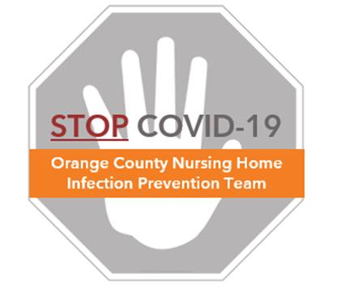

**Guidance for Staff:**

**Social Distancing, Universal Masking, and Break Activities**

To maintain safety of staff members working in healthcare settings, Centers for Disease Control and Prevention (CDC) and California Department of Public Health recommend social distancing and universal masking, as detailed below.

**Social Distancing**

* Limiting face-to-face contact among staff is key to reducing the spread of COVID-19
* Social distancing, also called “physical distancing,” is the practice of maintaining space – ideally 6 feet, when possible – between yourself and your co-workers. If 6 feet is not possible, then attempt to keep as much space as possible when conversing and interacting with co-workers, even if they are masked.
* CDC recommends spacing work stations apart and limiting group meetings to those where 6 feet of distance can be maintained
* Encourage workers to avoid carpooling to work or using public transit, if possible. If not possible, then avoid carpooling with any symptomatic persons and avoid sitting or standing within 6 feet of any persons, but especially symptomatic persons, while using public transit.
* Consider placing visual cues. You may use tape on the ground to mark 6-feet intervals in high traffic areas such as the entry symptom check in station, nursing stations, and break rooms.
* When it is not possible to maintain 6 feet, ensure you and those around you are masked
* Remember, despite social distancing, it is critical that sick staff members stay home

**Universal Masking**

* Staff should wear a mask at all times while working except when eating during breaks.
* When removing a mask for eating, place it in a clean bag. Do not place the mask directly on a table or surface unless you have just cleaned it with a disinfectant product.
* Staff can wear cloth masks from home (or provided by the facility) when not providing direct resident care. A surgical/standard mask should be worn for resident care.
* Consider posting a reminder **(example provided)** to encourage proper mask use:
  + Clean hands every time before and after touching mask
  + Avoid touching face and mask
  + Mask must cover nose and chin
  + Do not put mask under chin, over forehead, or over one ear
  + 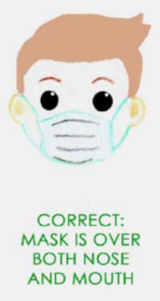Remove mask by touching only the straps (not the front)
  + Store mask in a clean, open bag for re-use
  + Put on a clean mask if mask becomes wet or soiled
  + Community cloth masks are reusable. Do NOT throw away.
  + Wash cloth mask between use with detergent at home

**Safety for Eating and Breaks**

* The highest risk period for staff is when a mask must be removed for eating and hands will be touching the face to eat. Be sure to follow the instructions below.
* Staff should maintain at least 6 feet from others, especially when the mask is off during breaks
* Breakrooms should be managed to allow for social distancing:
  + Post signs to remind staff to practice social distancing on breaks
  + Space chairs and tables apart or adding partitions to tables to maintain 6 feet between staff members when sitting.
  + Consider staggering break times or providing alternative break areas such as conference rooms or dining areas to maximize distance between staff
  + A dedicated COVID break area must be assigned for staff working in any dedicated COVID area of the facility
* Hand hygiene should be performed before and after removing your mask to eat, and repeated when putting the mask back on after eating.
  + Place handwashing stations or alcohol hand sanitizers in multiple locations to encourage hand hygiene. Staff should:
    - **Step 1:** Clean hands before removing a mask to eat
    - **Step 2:** Remove mask, fold, and store mask in a clean bag while you eat.

Do not place mask directly on a table or surface

* + - **Step 3:** Clean hands after putting mask in to bag
    - **Step 4:** Wipe table with disinfectant wipe, if available
    - **Step 5:** Place food items on a clean surface (plate or napkin). Do not place

food items directly on the table

* + - **Step 6:** Enjoy your meal
    - **Step 7:** Put all of your food away. Ensure table is cleared off.
    - **Step 8:** Clean hands
    - **Step 9:** Put mask back on and put bag away in your pocket
    - **Step 10:** Clean hands one last time
* For staff who smoke or use tobacco products during breaks:
  + Clean hands before and after use of cigarettes/vapes/smokeless tobacco
  + Avoiding these products is good for your health and may reduce infection risk
* For more information, see the **FAQ for Staff: Social Distancing, Universal Masking, and Breaks.**