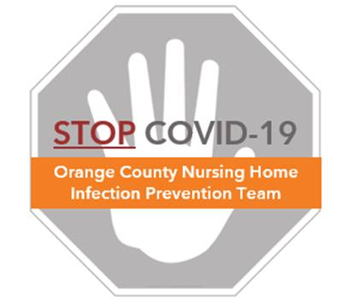

**Hand Hygiene**

**Frequently Asked Questions (FAQs)**

**Why is hand hygiene so important?**

* Keeping your hands clean is one of the most important ways to avoid getting sick and spreading germs, including the virus that causes COVID-19
* CDC recommends thorough cleaning of your hands (see *Hand Hygiene Protocol*)

**What should I use to wash my hands?**

* If your hands are visibly clean, you can use either soap and water or alcohol hand sanitizer, whichever one is readily available. Be sure that the alcohol hand sanitizer contains at least 60% ethanol or at least 70% isopropanol to be effective.
* If your hands are soiled, you need to wash your hands with soap and water.
* Whether at work, home, or outside, you should keep a small bottle of alcohol hand sanitizer on you for personal use to ensure you have it handy when you need it.

**Do I really need to clean the back of my hands too?**

* Yes. Proper hand hygiene involves rubbing all surfaces of your hands with soap or alcohol hand gel, including the front and backs of your hands, in between your fingers, both your thumbs, and under your nails.
* Rubbing your hands with soap or alcohol hand gel creates friction, which helps remove dirt, grease, and germs from your skin. Germs can easily become trapped under the nails, so be sure to clean under your nails.

**Can I use gloves instead of frequent hand hygiene?**

* No. Gloves do NOT replace the need to frequently clean your hands.
* Gloves should be worn when you are performing soiled activities (e.g. bathing, cleaning up incontinence, changing a dressing, cleaning a wound). Gloves should be removed as soon as the activity is done and hand hygiene should always be performed before and after glove use.
* In fact, because unclean hands can contaminate gloves and because taking off used gloves can cause hand contamination, hand hygiene should always be performed immediately before and after glove use
* Some people are wearing gloves all the time to protect themselves from COVID-19. This is not recommended and can be harmful. People often put on gloves and then forget that the outside of those gloves is contaminated. They feel safe, but then touch their face and belongings with contaminated gloves. Gloves also produce fear in others who wonder what soilage is on the gloves that are now touching common objects. It is better not to wear gloves and to simply use soap and water or alcohol hand sanitizer to clean your hands when they are dirty and especially before eating or touching your mask or face.

**My hands feel dry from so much washing. What can I do?**

* Increased hand washing can lead to dry hands if you are not used to this activity.
* It is important to keep your hands moisturized. Some soaps and hand sanitizers contain moisturizing ingredients to prevent dryness. Use hand lotion to prevent and/or treat dryness and cracking.