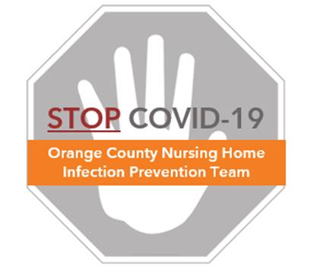

**Preventing COVID-19 in Nursing Homes**

**Hand Hygiene Protocol**

**Critical Moments for Hand Hygiene**

***Clean hands save lives!***

*Perform hand hygiene during*

*these critical moments*

* ANY TIME **your hands are visibly soiled**
* BEFORE and AFTER **touching your face or mask**
* BEFORE and AFTER **putting on/removing gloves**
* BEFORE and AFTER **eating**
* AFTER **using the restroom**
* BEFORE and AFTER **performing resident care needs**:

|  |  |  |
| --- | --- | --- |
| * **Feeding** * **Oral care** * **Giving medication** | * **Accessing devices** * **Bathing/showering** * **Toileting/incontinence care** | * **Dressing/undressing** * **Transferring** |

NOTE: If feasible, install hand sanitizer dispensers at the entrance and exit of residents’ rooms

|  |  |
| --- | --- |
| **Soap & Water**     1. **Wet** your hands with clean, running water and apply soap. 2. **Lather** soap by rubbing your hands together. Do not forget the backs of your hands, between your fingers, your thumb, and under your nails. 3. **Scrub** your hands for at least 20 seconds. (This is about the time it takes to sing the “Happy Birthday” song twice) 4. **Rinse** your hands well under clean, running water. 5. **Dry** your hands using a clean towel or air-dry them. | **Alcohol Hand Sanitizer\***  **(>60% ethanol or >70% isopropanol)**     1. **Apply** hand sanitizer generously into the palm of your hand (left or right). Ensure enough hand sanitizer to perform the following: 2. **Rub** the gel onto the front and back of both hands 3. **Rub** the gel between the fingers by interlocking the fingers of both hands. Remember to clean both thumbs. 4. **Rub** the gel onto both wrists 5. **Air** **dry**   * Non-alcohol-based formulations (e.g., benzalkonium chloride) are not recommended. Also,  ensure hand sanitizer is not contaminated with methanol, which is toxic. Check for recalled products at  <https://www.fda.gov/drugs/drug-safety-and-availability/fda-updates-hand-sanitizers-consumers-should-not-use> |