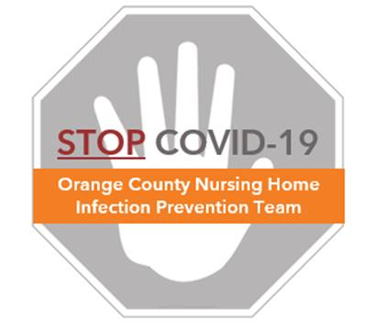

**COVID-19 Supply Preparation Checklist**

This list provides a quick reference for products your facility needs to safely care for COVID residents.

**Personal Protective Equipment (PPE)**

* Surgical masks, Level I/III masks – for general care of COVID-positive residents
* N95 masks – for aerosol generating procedures
* Protective eyewear options
  + Face shields – covers full face including eyes and masks. Preferred since this protects masks from contamination and allows for extended reuse of masks.
  + Goggles or safety glasses – covers eyes including complete side coverage.
  + NOTE: eyeglasses are **not** acceptable protective eyewear.
* Gowns
  + Washable or disposable gowns (Level 1 AAMI) are acceptable
  + Must provide complete coverage for front and back
* Gloves

**Hand Hygiene**

* Alcohol based hand rub/sanitizer – must contain more than 60% ethanol or 70% isopropanol
  + NOTE: warnings exist against use of methanol, which is toxic
* Hand sanitizer dispensers – bottles and pumps for areas without wall mounted dispensers
* Hand soap – refills for sink liquid soap dispensers
* Paper towels for drying hands if using soap/water

**Personal Hygiene and Decolonization for Residents (CalOptima PIPQI program, Orange County, CA)**

* 4% rinse-off chlorhexidine (CHG) for showers
* 2% leave-on CHG for bed baths
* 10% Iodophor nasal swabs

**Cleaning Products – Resident and Staff Areas**

* Disinfectant – any EPA registered household disinfectant
  + <https://www.epa.gov/pesticide-registration/list-n-disinfectants-use-against-sars-cov-2-covid-19>
  + Cleaning wipes
  + Cleaning solution
* Alcohol swabs - to clean items between residents (e.g., glucometer, stethoscopes, face shields)
* Laundry hampers and trash bags for increased PPE laundry and disposal

**COVID Testing Supplies (generally provided by the laboratory)**

* Nasal or nasopharyngeal swabs – sterile synthetic fiber swabs with plastic or wire shafts only
* Sterile transport tubes containing 2-3mL of either viral transport medium or sterile saline
* Lab specimen bags and labels