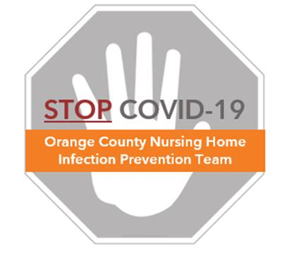

**Staff Safety: Aerosol Generating Procedures**

**Frequently Asked Questions (FAQs)**

**What is the difference between droplet and airborne transmission?**

* COVID-19 is spread through droplets and close contact with respiratory secretions that are introduced through the mucus membranes of the eyes, nose, or mouth
  + Droplet transmission involves infectious drops of larger size (>5 – 10 µm) (e.g., Influenza, COVID-19), which are small enough to be invisible to the eye.
  + These droplets fall by gravity within a short distance after a cough or sneeze. Unlike airborne diseases, these droplets are too big and heavy to travel long distances or suspend in the air for a long period of time.
* Airborne transmission is the spread of infectious pathogens through very small particles (<5 µm) that can remain suspended in air over a long distance and time. (See the document called “FAQs for Staff – Aerosol Generating Procedures”)
  + Examples of pathogen known to be truly airborne spread are TB, measles, and chicken pox.

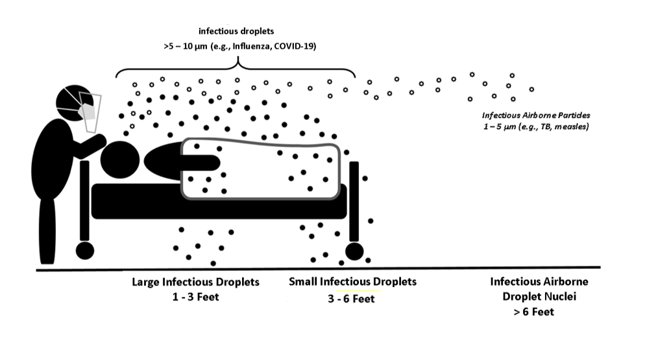

**What are aerosol-generating procedures?**

* Aerosol generating procedures (AGP) are procedures or treatments that have the potential to generate aerosols that can be suspended into the air as very fine particles within the local environment
* These fine particles can be inhaled by persons in very close proximity to the resident.
* When performing these procedures, all staff in the room must wear an N95 respirator
* The vast majority of resident care does not generate aerosols that require N95respirators
* Procedures that can be aerosol generating and need N95 respirator protection include: (also see the document called “Aerosol Generating Procedures Protocol”)
  + Open airway suctioning (not in-line suctioning or suctioning of oral mucosa) such as tracheostomy suctioning
  + Cardiopulmonary resuscitation
  + Non-invasive positive pressure ventilation (BiPAP, CPAP)
  + Nebulizer therapy (use metered dose inhalers (MDI) instead, when possible)

**What PPE do I wear when performing an AGP on a resident with COVID?**

* During an AGP, all staff within the room should wear an N95 respirator plus eye protection (e.g. full face shield for splash barrier).
* Ensure only necessary people are in the room
* Gowns and gloves are also required for all COVID positive residents

**After an AGP, how long should I wear the N95 respirator?**

* The aerosol droplets produced during an AGP are localized to the immediate environment and short-lived.
* N95s are no longer necessary once the procedure is complete. All healthcare workers wearing an N95 respirator may transition back to a regular mask at the next room entry.
* You can reuse the N95 if you follow the guidance in the “N95 Reuse Protocol”

**Where can I go to learn more?**

* Visit the World Health Organization Scientific Brief on Transmission of SARS-CoV-2:

<https://www.who.int/news-room/commentaries/detail/transmission-of-sars-cov-2-implications-for-infection-prevention-precautions>

* Refer to the **OC Nursing Home COVID-19 Infection Prevention Toolkit** for more information and additional FAQs at ucihealth.org/stopcovid