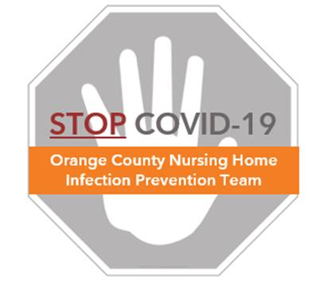

**COVID-19 and Clothing, Hair, and Shoes**

**Frequently Asked Questions (FAQ)**

**Should I be concerned about spread of COVID-19 through clothing?**

* Clothing is not a primary source of COVID-19 transmission. The virus does not go through clothing to infect you.
* To address potential germs on the surface of your clothes, consider changing out of “work clothes” into clean “home clothes” when returning home from your nursing home shift.
* Over-the-counter laundry detergent will easily kill the virus at any temperature if used in proper amounts
  + You can wash your clothing along with other members of your household
  + Dry clothes at the temperature recommended on the clothing label
  + Clean hands thoroughly after handling soiled laundry

**Should I use bleach to decontaminate my shoes?**

* There is no need to clean the bottom of your shoes with bleach. The COVID-19 virus does not go through shoes to infect you.
* True exposure to COVID-19 occurs when droplets from an infected individual are transferred to your eyes, nose or mouth. For your shoes to be a problem, an infected person would have to cough or sneeze onto the floor, get picked up by your shoes, and then you would have to touch the bottom of your shoes and then touch your eyes, nose, or mouth without cleaning your hands. Thus, exposure through this route is unlikely.

**Do I need to cover my hair?**

* While a bouffant may be helpful for keeping hair out of your face and catching hair strands from falling into food, it will not provide additional protection from COVID-19.
* The virus that causes COVID-19 does not transmit through the hair. Transmission occurs when an infectious person talks, coughs, sneezes, or shouts infected droplets into the eyes, nose, or mouth of another person OR when an infected person touches an object and another person touches the same object within hours, even up to 1-2 days and then rubs his/her eyes, nose, mouth or eats without cleaning hands beforehand.
* Thus, remembering to **clean your hands every time before you touch your face, eyes, nose or mouth, and before eating** will keep you safe even if you touch or handle contaminated objects.

**Where can I go to learn more?**

* Additional information can be found at the CDC website or at the California Department of Public Health website
  + <https://www.cdc.gov/coronavirus/2019-ncov/if-you-are-sick/steps-when-sick.html>
  + <https://www.cdph.ca.gov/Programs/CID/DCDC/Pages/Immunization/nCOV2019.aspx#What%20if%20I'm%20sick?>
* Refer to the **OC Nursing Home COVID-19 Infection Prevention Toolkit** for more information and additional FAQs at ucihealth.org/stopcovid