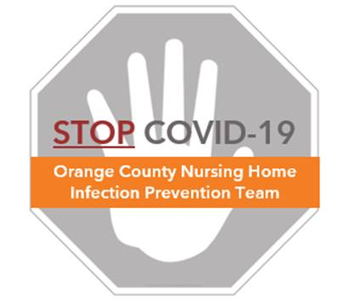

**Staff Safety: Masking**

**Frequently Asked Questions (FAQs)**

**Why is masking important?**

* A facemask prevents the spread of germs.
  + It prevents people who are sick from transmitting illness to others.
  + It provides a barrier so that droplets from someone who is ill do not reach your eyes, nose or mouth
* Universal masking means that all community members must wear a mask when sharing common spaces
* This is especially important in nursing homes, where germs can spread between staff and residents
* ***All staff should be masked at work, regardless of symptoms.***

**Is masking really effective?**

* Yes. Studies have shown that masking can significantly reduce the spread of germs by preventing germs from a coughing or sneezing person from reaching another person
* The spread of coronavirus was controlled faster in countries with widespread masking
* All types of masks offer protection – cloth, standard surgical masks, and N95 respirators

**If I’m masked, why do I need to social distance?**

* Masking is one of many important ways to prevent spread of germs. Because human behavior is not perfect, use several ways to protect yourself from infection.
* Masking does NOT replace the need to
  + Keep a 6 foot distance from others whenever possible (social distancing)
  + Clean your hands before and after touching or readjusting your mask
  + Clean your environment in case the person touching items before you was ill
* Social distancing is the practice of keeping space between yourself and others to prevent spread of illness between people
* To practice social or physical distancing:



* + Stay 6 feet (about 2 arms’ length) from other people
  + Avoid crowding at nursing stations or break areas
* If 6 feet of distance is not possible at work, keep as much distance as you can and ensure all staff members are masked while working

**What is universal masking?**

* In keeping with CDC guidance issued in mid-April 2020, all persons should wear a mask outside of the home to control the spread of COVID-19. This is called universal masking.
* Staff should wear a community cloth mask from home (or one provided by the facility) when entering the facility.
* Staff whose job duties do not require resident care may wear a clean community cloth mask for source control while at work.
* Staff who provide direct care for residents should change from a community cloth mask to a surgical/standard mask when performing resident care duties.
* Stay at least 6 feet from others, whenever possible, even when you wear a mask.

**Masking: who, what, and where?**

* Community cloth masks may be worn during non-resident care activities. Please save disposable surgical/standard masks for direct care providers.
* Do not wear N95 respirators in hallways, nursing stations, or common areas. These are to be reserved for aerosol generating procedures (e.g. CPR, nebulizer treatment, tracheal suctioning) – See the document called “FAQs for Staff – AGPs”

|  |  |  |
| --- | --- | --- |
| **Who** | **What** | **Where** |
| Non-direct care providers | Community cloth mask | On arriving and leaving work  and continuously through the day |
| Direct care providers | Community cloth mask | On arriving and leaving work  Non-resident care areas  During administrative time (not providing resident care for all or part of day)  During breaks, if preferred |
| Direct care providers | Surgical/standard mask | Can be worn continuously in resident rooms or during resident care duties |

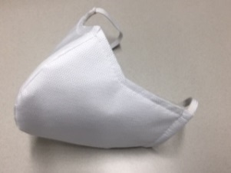 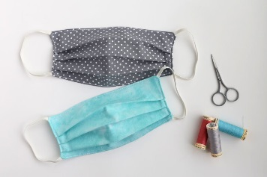 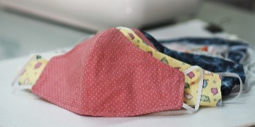

Examples of community cloth masks

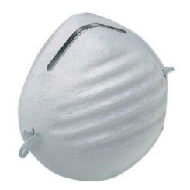

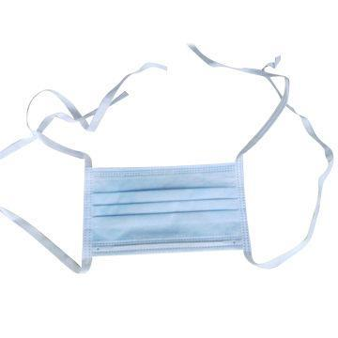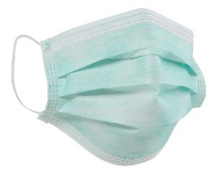

Examples of resident care masks

**Is a regular mask good enough? Do I need an N95 respirator?**

* Evidence supports COVID-19 is spread by direct large droplet spray and indirect environmental contamination.
* Regular masks are highly effective in trapping large droplets. Adding a face shield to this during resident care activities adds another layer of protection from sprays and splashes
* Most care of COVID-19 resident requires a standard resident care mask with face shield.

**Is COVID-19 airborne?**

* COVID-19 is primarily spread through large droplets and close contact with respiratory secretions that are introduced through mucus membranes of the nose, mouth, or eyes
  + Droplet transmission involves infectious drops of larger size (>5 – 10 µm) (e.g., Influenza, COVID-19), which are small enough to be invisible to the eye.
  + These droplets fall by gravity within a short distance after a cough or sneeze. Unlike airborne diseases, these droplets are too big and heavy to travel long distances or suspend in the air for a long period of time.
* Airborne transmission is the spread of infectious pathogens through very small particles (<5 µm) that can remain suspended in air over a long distance and time. (See the document called “FAQs for Staff – Aerosol Generating Procedures ”)
  + Examples of pathogens known to be truly airborne spread are TB, measles, and chicken pox.
  + Certain procedures can aerosolize COVID-19

**What is an N95 respirator and when do I need it?**

* An N95 respirator is a mask that fits with a tight seal around the nose and mouth
* It filters out at least 95% of particles in the air
* Because COVID-19 is primarily spread by larger droplets (>5 – 10 µm), standard face masks are effective protection in usual daily resident care activities
* However, certain procedures can aerosolize COVID-19 into very small droplets. ***During these procedures, staff must wear an N95 respirator*** (See “AGP Protocol” and “FAQs for Staff – AGPs”)

**Does it help to double-mask?**

* No. A single mask effectively provides a barrier against the spread of droplets
* A second mask adds no additional benefit to a face shield and adds another layer of PPE that can get contaminated
* Masks were not designed for layering on top of each other and this practice could make breathing less comfortable and harder to tolerate

**I’m not used to wearing a mask all day. What is the safe way to wear a mask?**

* This is new for all of us. The best way to learn how to do it is through practice.
* Wearing a mask can cause people to touch their face more due to the need to adjust the mask. **Frequent touching of the mask/face can, unintentionally, increase the likelihood of exposure to COVID-19 if hands are not clean.**
* Here are some key pearls about how to wear a mask. ALL of these take practice.
  + Mask should cover nose, mouth, and chin
  + Try your best to avoid touching your face and mask
  + If you must touch or adjust your mask, clean your hands **every time** before & after
  + Do not put your mask under your chin, over your forehead or over one ear
  + Store mask in clean paper bag or clean, thin, open plastic bag for re-use
  + Put on a clean mask if wet, soiled, or damaged
  + For cloth masks, wash mask between use with detergent at home
  + Masks can be re-used unless wet, soiled or damaged.

|  |  |
| --- | --- |
| **DO** | **DON’T** |
| * Wear community cloth mask on arrival to work and when going home * Masks must be worn all day at work, even by non-direct care providers * Cloth masks can be worn in non-resident care areas, during administrative time and breaks by direct care providers * Perform hand hygiene before and after putting on, taking off, or adjusting your mask. * Remove mask by grasping ear loops or ties and directly removing away from face. * Store in a clean, unsealed bag for reuse. * Protect your mask under a face shield when caring for an unmasked resident and anytime when splash or spray could occur | * Don’t touch or adjust the mask with unclean hands * Avoid touching the inside of your mask if possible * Don’t remove mask by grasping the front of it * Don’t reuse your mask if it is wet, soiled, damaged, loses function (e.g. unable to breathe through) or the fit cannot be maintained * Don’t wear mask on chin, top of head or hanging over one ear * Don’t double mask * Don’t wear your community cloth mask into resident rooms if you are a direct care provider |

**How do I clean my cloth mask?**

* The novel coronavirus, SARS CoV-2 is easily killed by standard laundry detergent.
* Wash in laundry machine or by hand.
* Bring an extra clean cloth mask in case one becomes soiled or wet during the day.

**Will residents and permitted visitors be required to wear a mask?**

* Residents should be encouraged to wear a mask when leaving their room or when staff enter the room for care, if tolerated
* Visitors are restricted except for end-of-life circumstances. All visitors must wear masks.
* Remind visitors to bring their own masks to preserve the mask supply for staff. If visitors do not bring their own masks, a disposable mask should be provided.

**Are there any health issues I should look out for when wearing a mask all day?**

* Masks are generally safe to use all day
* Because the skin of our face is more fragile than other parts of our body, some staff develop skin irritation from continuous mask use. Cloth masks made of 100% cotton minimizes this risk while still providing protection for non-direct resident care duties.
* In rare cases, people who wear tight masks all day can develop side effects that include buildup of carbon dioxide in the air enclosed within the mask.
  + This can occur when wearing very tight fitting masks or N95 respirators.
  + Do not wear more than one mask at a time.
  + The symptoms of carbon dioxide buildup can include tiredness, sleepiness, feeling dizzy, or headache. To avoid this, remove your masks during outdoor breaks when able to be separated by at least 6 feet from another person.

**When am I allowed to take off my mask?**

* To avoid touching and adjusting your mask, it is recommended to leave your mask on at all times, except when needing to remove it for breaks, lunch or when leaving work.
* Remember it is very important to keep at least 6 feet of distance from all other people when your mask is off to eat.
* When alone in a personal office, masks can be removed if not encountering other persons within 6 feet.
* Remember to clean your hands immediately before and after taking off and putting on your mask. Store masks in a clean breathable bag (open plastic or paper bag).

**Where can I go to learn more?**

* Visit the World Health Organization Scientific Brief on Transmission of SARS-CoV-2:

<https://www.who.int/news-room/commentaries/detail/transmission-of-sars-cov-2-implications-for-infection-prevention-precautions>

* Refer to the **OC Nursing Home COVID-19 Infection Prevention Toolkit** for more information and additional FAQs at ucihealth.org/stopcovid