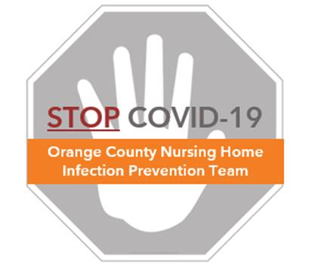

# Doffing COVID Personal Protective Equipment

**Before Exiting Room/COVID Dedicated Area**

## ❶ Determine doffing process, which depends on whether

## Gown can be removed by tugging from front to unsnap

## Gown must be untied by reaching up behind neck or behind back

|  |  |
| --- | --- |
| **OPTION A**  **(gown can be tugged off from front)** | **OPTION B**  **(must reach behind neck/back)** |
| **❷ Remove gown**   * Grasp front of gown at upper chest or waist level. Tug to remove. * Turn gown inside out, bundle and place in proper container   **❸ Remove gloves**  **❹ Perform hand hygiene** | **❷ Remove gloves**  **❸ Perform hand hygiene**  **❹ Remove gown**   * Unsnap or untie at neck and back * Turn gown inside out, bundle and place in proper container   **❺ Perform hand hygiene** |

* **When removing gloves,** use glove in glove technique (see “Glove Removal Video”)
* **When performing hand hygiene,** ensure cleaning of all surfaces of the hands, including front, back, in between the fingers, the thumbs, the wrists, and the tips of all fingers

**NEXT, complete PPE removal with the following steps:**

**❶ Remove face shield**

* Tilt your head forward, hold the top of your face shield with one hand, and pull the shield off the top of your head
* Clean face shield/goggle if reusing (see “Eye Protection Reuse Protocol”)

**❷ Remove mask/N95 respirator**

* Under universal masking, retain standard mask unless soiled, wet, or damaged
* Remove N95, store per “Mask Reuse Protocol”, don standard mask

## ❸ Perform hand hygiene