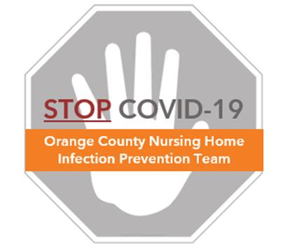

**Donning COVID Personal Protective Equipment**

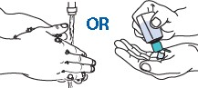

**Before Entering Room/COVID Dedicated Area**

**❶ Perform hand hygiene (alcohol hand rub or soap/water)**

* Ensure cleaning of all surfaces of the hands, including front, back, in between the fingers, the thumbs, the wrists, and the tips of all fingers

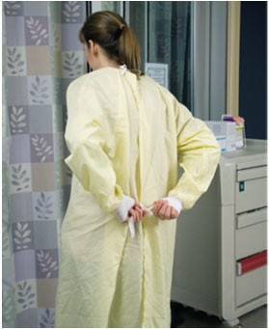**❷ Put on clean gown**

## Ensure gown is clean. Do not put on a used gown previously used by you or anyone else.

## Secure at back of neck and waist

* Ensure cuffs cover wrists

# ❸ Perform hand hygiene again

* Ensure cleaning of all surfaces of the hands, including front, back, in between the fingers, the thumbs, the wrists, and the tips of all fingers

**❹ Put on standard mask (already on if extended use) or N95 respirator**

* 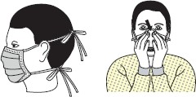Reserve N95 for aerosolized generating procedures
* If using an N95, check seal by cupping hands around edge of mask and blowing to see if air leaks around mask. If air leaks, readjust mask and check seal again. If unable to seal, replace N95

**❺ Put on face shield (or safety glasses or goggles)**

* May already be on if applying extended use in COVID dedicated areas

# ❻ Perform hand hygiene again

* Ensure cleaning of all surfaces of the hands, including front, back, in between the fingers, the thumbs, the wrists, and the tips of all fingers

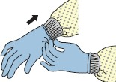**❼ Put on gloves**

* Extend to cover wrist on top of gown