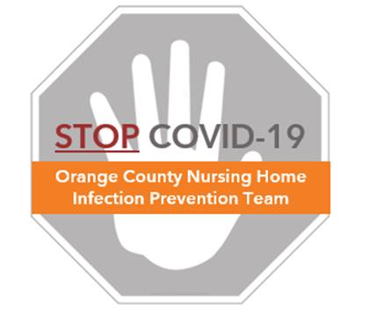

**Preventing COVID-19 in Nursing Homes**

**Eye Protection Protocol**

**Eye Protection**

* Used to protect your eyes from splash or spray
* Must cover the front and entire side around the eyes
* Acceptable examples include safety glasses, goggles, or face shields
* Full-face shields are preferred because they protect your mask from contamination
* NOTE: eyeglasses and contact lenses do NOT provide sufficient protection.

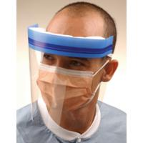

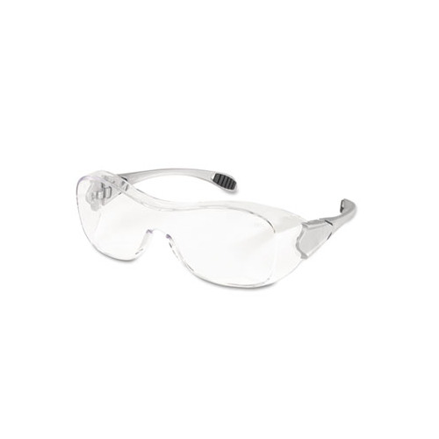

**When to Use Eye Protection**

* When providing direct care for confirmed or suspect COVID residents
* Remove eye protection when leaving resident room or COVID dedicated area
* Avoid use in hallways or common areas unless in a COVID dedicated area

**Donning (Putting On) Eye Protection**

* Clean your hands with alcohol hand sanitizer or soap/water
* Follow directions on donning your surgical mask or N95 respirator. Ensure that the mask fits well to minimize the need for adjustment after the face shield is added.
* Holding the face shield with one hand, pull the strap over the top of your head with your other hand
* Adjust the shield to the center of the face, assuring snug fit when moving your head
* If using goggles, assure both sides of the goggles are secured snugly behind your ears
* Follow directions on donning your gown and gloves (see COVID PPE protocol)
* Clean your hands immediately after donning face shield

**Doffing (Taking Off) Eye Protection**

* Clean your hands with alcohol hand sanitizer or soap/water
* Avoid touching the front of your face shield or goggles
* Face shield removal: tilt your head forward, hold the top of your face shield with one hand, and pull the shield off the top of your head
* If reusing, follow the PPE reuse protocol (See “Eye Protection Reuse Protocol”)
* Goggle removal: tilt your head forward, hold both sides of the goggles and pull away from your face.
* Goggles are usually designed to be reused and should be cleaned with alcohol swab or disinfectant wipe and returned to a clean bag/storage for reuse. (See “Eye Protection Reuse Protocol”)

**Keeping Your Eye Protection Clean**

* Perform hand hygiene every time before and after touching your face shield/goggles
* Minimize touching your face shield/goggle, especially the inside surfaces
* Clean your face shield/goggle if planning to reuse (see “Eye Protection Reuse Protocol”)