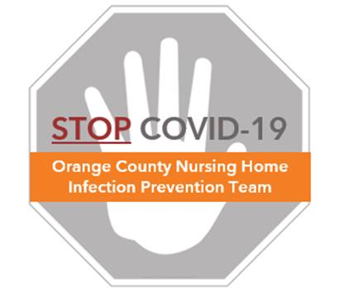

**Preventing COVID-19 in Nursing Homes**

**Mask Reuse and Extended Use Protocols**

Protecting the supply of personal protective equipment (PPE) is important to assure the current and future health of residents and healthcare workers. N95 respirators and surgical masks can be **safely re-used to protect supplies during an outbreak or pandemic.**

**Definitions:**

**Reuse** refers to the practice of using the same PPE for multiple encounters with different residents, but removing it (‘doffing’) after each encounter.

**Extended** use refers to the continuous wear of the same PPE (e.g., N95 respirator) for serial or repeated close contact encounters involving multiple residents, without removing the PPE between resident encounters. For the COVID-19 pandemic, extended use of standard masks is in place for universal masking.

***NOTE: If splash, spray, or aerosol generation occurs, replace mask.***

The following re-use guidance aligns with recommendations from CDC and CalOSHA:

**Reuse of Standard Masks & N95 Respirators**

* Can be re-used unless wet, soiled, damaged, or the fit cannot be maintained.
* Can be safely reused over multiple days or shifts
* Can be used by the same healthcare worker between multiple residents
* Do not allow healthcare workers to use same mask
* Replace any mask or respirator that is contaminated with any direct splash or spray
* Replace if used during an aerosol generating procedure with a resident with confirmed or suspect COVID (see AGP Protocol for a list of AGPs)

**How to Safely Reuse Standard Masks & N95 Respirators**

* Follow the doffing protocol for standard masks and N95 respirators (see “FAQ for Staff – Masking”), assuring hand hygiene is done before and after touching your mask
* Place the mask into a clean breathable bag, either a paper bag or a thin plastic bag that is not sealed
* Orange County Health Care Agency recommends use of CDC’s rotating N95 respirator use if N95 use is required and respirators are in limited supply.
  + Provide 5 respirators, each to be stored in breathable bag marked with name and 1-5.
  + Wear one respirator in sequence each shift that it is needed, ensuring at least 72 hours of “rest” between uses which ensure any virus on the respirator is dead.
  + Discard if visibly soiled, wet, damaged, or loses fit
  + <https://www.cdc.gov/coronavirus/2019-ncov/hcp/respirators-strategy/index.html>

|  |  |
| --- | --- |
| **Reuse** | |
| * Clean and Dry * Nosepiece Intact * Straps Intact * Fit Maintained * No Tears in Mask * No Deformation in Shape * No visible soilage |  |
| **Discard** | |
| * Detached/fractured nosepiece * Torn, damaged * Deformed, no longer fits * Visibly soiled, contaminated * Broken or stretched straps |  |

**Keeping Your Standard Masks and N95 Respirators Clean**

* Perform hand hygiene every time before and after touching the respirator
* In general, avoid touching your mask, especially the inside of the respirator
* Preferentially use a face shield rather than goggles when caring for COVID-19 residents to prevent your mask/N95 from being contaminated

**Extended Use of Masks/N95 Respirators – General Principles**

* Extended use of standard masks (continuous wear between multiple residents) is in place due to universal masking. If needed for aerosol generating procedures, extended use of N95 respirators should be allowed only in dedicated COVID areas where all residents within that zone (e.g. RED Zone) have confirmed COVID by PCR testing.
* Both types of masks (standard, N95 respirators) are eligible for extended use.
* If splash, spray, damage or loss of fit occurs at any time, then replace mask.
* Avoid touching the mask as much as possible.
* To adjust mask, remove gloves and perform hand hygiene **before and after** touching your mask

**How to Safely Practice Extended Use of Masks/N95 Respirators**

* Given universal masking, extended use of a standard mask is already in place. For N95 respirators, don upon entry to the dedicated area where extended use is permitted (See “COVID N95 Respirator Protocol”), assuring hand hygiene is done before and after touching any mask/respirator.
* Note that while extended use is permitted for masks, eye protection, and gowns between residents in the COVID Dedicated Area (e.g. RED Zone), gloves should be changed between residents and hand hygiene should be performed each time between residents. Glove exchange and hand hygiene should continue to be performed per usual best practice.
* Upon leaving the room or COVID Dedicated area, apply reuse processes. Standard masks may remain on for universal masking. N95 respirators should be doffed (See “COVID N95 Respirator Protocol”) and stored in a clean bag for next re-entry or use unless visibly soiled, wet, or damaged.