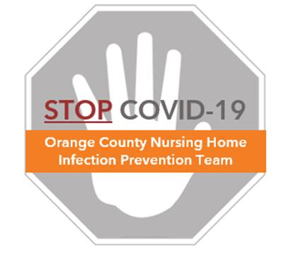

**Preventing COVID-19 in Nursing Homes**

**N95 Respirator Protocol**

**N95 Respirators**

* Are masks that fit with a tight seal around the nose and mouth
* Filter out at least 95% of particles in the air
* Designed to protect against very small airborne particles
* Examples include:

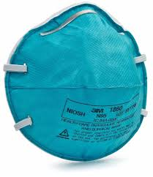 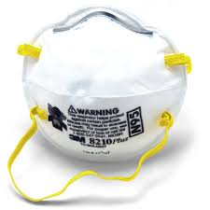 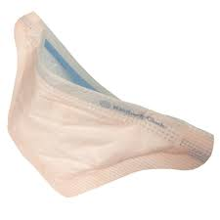

**When to Use N95 Respirators**

* Should be reserved for aerosol-generating procedures (AGP) (e.g. CPR, nebulizer treatment, tracheostomy suctioning) in residents with COVID-19 (see “AGP Protocol”)
* Standard surgical masks should be used for direct resident care not involving AGPs
* After performing the AGP, remove the N95 respirator when doffing PPE upon leaving the resident’s room or designated area. If re-use protocols are in place, put the mask in a clean breathable bag rather than discarding (See “Mask Reuse Protocol”).
* Replace the mask if wet, soiled, or damaged, including if any spray or splatter occurred.
* Do not wear an N95 respirator between AGPs involving different residents, in hallways, or common areas unless in a dedicated COVID area approved for extended re-use.

**Donning (Putting On) an N95 Respirator**

* Clean your hands with alcohol hand sanitizer or soap/water
* Take a provided N95 mask or a stored mask per re-use protocol
* Place over your nose and mouth
* Pull the top strap to the top, back part of your head above the ears
* Pull the bottom strap to the nape of your neck below the ears
* Gently mold the hard section around the bridge of your nose for a snug fit
* Clean your hands with alcohol hand sanitizer or soap/water
* Ensure your N95 respirator covers and seals tightly around your nose and mouth by performing a seal test (blow air into the mask while your hands are cupped around the edge of the mask to feel for air leaks). If air leaks around the mask, reposition the mask until the mask passes the seal test. If unable to obtain a secure seal, obtain a new N95 respirator and try again.
* When worn correctly, you should feel the mask pulling inwards when breathing in and pushing outwards when breathing out.
* Fit testing is recommended for use of N95 respirators, but is dependent on local public health guidance if fit testing is not available. For Orange County, California nursing homes, fit testing is not a requirement at this time.

**Doffing (Taking Off) an N95 Respirator**

* Clean your hands with alcohol hand sanitizer or soap/water
* Avoid touching the front of your respirator
* With your head tilted forward, pull the bottom and top straps over your head. Start with the bottom straps and pull them with the top straps until both are free.
* If re-use protocols are in place, and your N95 mask is not wet, soiled, or damaged, store your N95 in a breathable bag (see “Mask Reuse Protocol”)
* Replace the N95 if it becomes wet, soiled, damaged, or does not fit properly
* Clean your hands immediately after mask removal

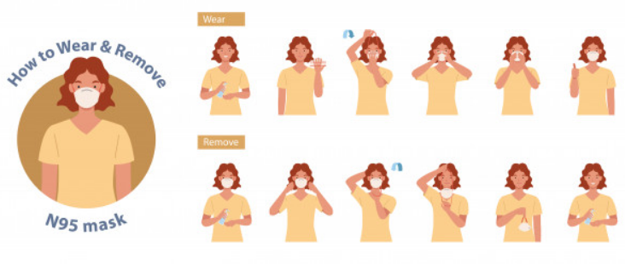

**Keeping Your N95 Respirator Clean**

* Perform hand hygiene every time before and after touching the respirator
* In general, avoid touching your mask, especially the inside of the respirator
* Use a face shield when caring for COVID-19 residents to prevent your N95 from being contaminated, allowing safe N95 reuse (see “Mask Reuse Protocol”)