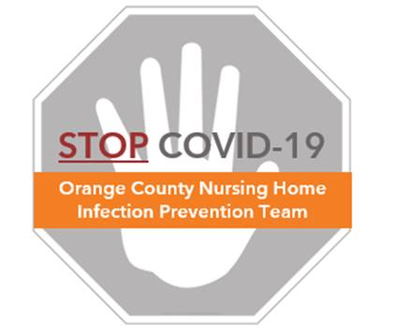

**Frequently Asked Questions (FAQs)**

**Environmental Cleaning**

**Germs in the Environment**

**What is environmental cleaning?**

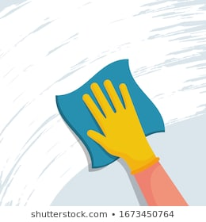

* Environmental cleaning is an important infection prevention practice that involves routine cleaning and disinfecting
* Cleaning helps to remove germs that can live on surfaces and cause disease in humans

**How do germs spread in nursing homes?**

* Humans touch surfaces and transfer germs onto those surfaces
* For example, if an infected resident coughs on an object, germs will be transferred onto the object. If a healthcare worker then touches the object, their hands will become contaminated. If that healthcare worker doesn’t wash their hands, then they can become infected or they can infect others whom they touch.
* People who transfer germs can be obviously sick with those germs, or they can be only mildly sick or silent carriers. Some examples include:
  + People may carry methicillin-resistant *Staphylococcus aureus* (MRSA) on their skin or in their nose and not have any symptoms
  + People infected with COVID-19 not only shed virus when they are sick, but they are often contagious and shed virus for a day or two before symptoms begin

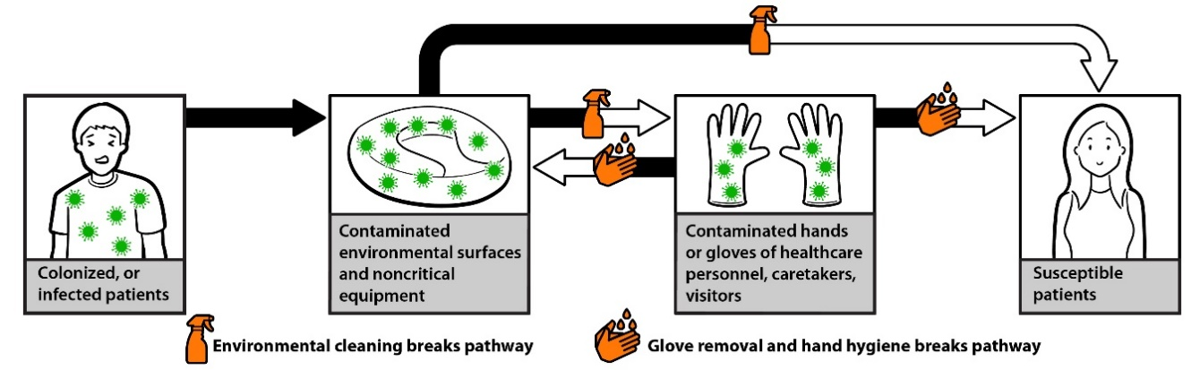

**Figure source:** CDC.gov/hai/prevent/resource-limited/introduction.html

**How can we reduce the spread of germs in our nursing home?**

* To reduce the spread of germs, surfaces that may be contaminated must be cleaned and disinfected on a routine basis, usually at least once per day. This is especially important for high-touch surfaces.
* For additional strategies to keep your nursing home safe, visit the Nursing Home COVID Prevention Toolkit: **ucihealth.org/stopcovid**

**How long do germs live on surfaces?**

* Different germs can live on surfaces for different amounts of time
* Viruses generally live on surfaces for many hours. The virus that causes COVID-19, called SARS-CoV-2, can survive for up to 1-2 days on certain surfaces.
* Bacteria usually live on surfaces longer. For example, MRSA can survive on objects for weeks to months.
* Since viruses and bacteria can live outside of the body, it is best to clean and disinfect surfaces regularly

**What germs does environmental cleaning protect against?**

* EPA-approved disinfectants remove bacteria (such as MRSA, and extended-spectrum beta-lactamase producers (ESBL)), viruses (such as SARS-CoV-2), and fungi (such as Candida species)
* Refer to your manufacturer product label for more information about how long the product needs to stay wet on surfaces to kill different germs

**Cleaning & Disinfecting**

**What is the difference between cleaning and disinfecting?**

* **Cleaning** involves wiping and rubbing to remove dust, grime, oil/grease, debris, and organic material (bodily fluids, microorganisms). It also includes tidying up.
* **Disinfecting** should be done after cleaning to kill and remove germs from surfaces using an EPA-approved disinfectant.
* **Both are needed.** If you do not first clean off the grime and debris, you can’t kill the germs under or around it, and the surface can still be contaminated.

**What products are best for cleaning and disinfecting?**

* Cleaning products typically include soaps and detergents, but will depend on the surface to be cleaned. For example, general cleaner is used on floors and glass cleaners are used on glass or mirrors.
* Disinfectant products commonly include quaternary ammonium, bleach, or hydrogen peroxide

**What cleaning methods are necessary to remove and kill germs on surfaces?**

* For general surfaces, a cleaning cloth and disinfectant are needed to remove grime and dirt, and to kill germs on surfaces
* Some hard-to-kill pathogens require diluted bleach. For example, cleaning the room of a resident with *C. difficile* requires disinfecting with diluted bleach.
* Refer to the “Protocol – General Cleaning Practices” for more information

**How often should surfaces be cleaned?**

* The way we clean a room and how often we clean it depends on the type of room and the activities that take place in it. For example, a resident’s room may need daily cleaning, a dining room may need cleaning after each meal, and rehabilitation equipment will need cleaning after each use.
* Use the chart below to determine cleaning frequency and method:

|  |  |  |
| --- | --- | --- |
| **Room/Object Type** | **Frequency of Cleaning** | **Surfaces to be Cleaned** |
| Standard Care Room | At least daily | High-touch surfaces and floors |
| Weekly and when visibly soiled | Low-touch surfaces such as dresser tops, vents, walls, baseboards, corners |
| Resident Bathrooms | At least daily | High-touch surfaces and floors |
| Weekly and when visibly soiled | Low-touch surfaces such as walls, baseboards, corners |
| Common Areas | At least daily | High-touch surfaces and floors |
| Weekly and when visibly soiled | Low-touch surfaces such as shelves, bookcases, windows, walls, baseboards |
| Rehabilitation Equipment | Post-Use/Between Use | Clean all equipment after each use |

**Additional Information**

* Refer to the **OC Nursing Home COVID-19 Infection Prevention Toolkit** for more information and additional FAQs at ucihealth.org/stopcovid
* The Centers for Disease Control & Prevention (CDC) provides best practices for environmental cleaning in healthcare facilities:

[https://www.cdc.gov/hai/prevent/resource-limited/index.html](https://urldefense.com/v3/__https:/www.cdc.gov/hai/prevent/resource-limited/index.html__;!!OLgoXmg!HpJfTJ8B9HrRsqukeQJbTxMFJHRn6M0KhfBqoVqHEmU99pmgrnlAwzpiWnOH_C0$)