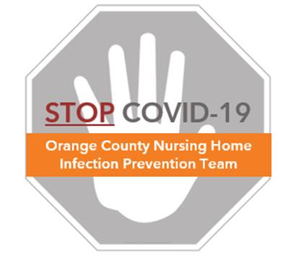

**Preventing COVID-19 in Nursing Homes**

**Housekeeping Skills Assessment Log**

**_________________________ _____/______/______**

**Last Name, First Name Date of Observation**

**Observer**

**_________________________ ________________________**

**Last Name, First Name Room # / Area**

**Housekeeper (1x a week)**

**Resident Room Cleaning**

|  |  |  |
| --- | --- | --- |
| **Object** | **Cleaned** | **Notes** |
| Light Switch | Yes □ No □ |  |
| Door Handle | Yes □ No □ |  |
| Footboard and Headboard | Yes □ No □ |  |
| Remote (TV, call button) | Yes □ No □ |  |
| Over Bed Table | Yes □ No □ |  |
| Nightstand | Yes □ No □ |  |
| Guest Chair | Yes □ No □ |  |

**Resident Bathroom Cleaning**

|  |  |  |
| --- | --- | --- |
| **Object** | **Cleaned** | **Notes** |
| Light Switch | Yes □ No □ |  |
| Door Handle | Yes □ No □ |  |
| Sink | Yes □ No □ |  |
| Dispensers | Yes □ No □ |  |
| Wall Handrails | Yes □ No □ |  |
| Toilet Flush Handle | Yes □ No □ |  |
| Toilet Seat / Chair | Yes □ No □ |  |

**Complete at least once weekly. See “Protocol – Housekeeping Observations” for more information.**

Protocol – Housekeeping Observations



**Preventing COVID-19 in Nursing Homes**

**Housekeeping Observed Skills Assessment**

**_________________________ _____/______/______**

**Last Name, First Name Date of Observation**

**Observer**

**_________________________ ________________________**

**Last Name, First Name Room # / Area**

**Housekeeper (1x a week)**

**Common Area**

|  |  |  |
| --- | --- | --- |
| **Object** | **Cleaned** | **Notes** |
|  | Yes □ No □ |  |
|  | Yes □ No □ |  |
|  | Yes □ No □ |  |
|  | Yes □ No □ |  |
|  | Yes □ No □ |  |
|  | Yes □ No □ |  |
|  | Yes □ No □ |  |
|  | Yes □ No □ |  |
|  | Yes □ No □ |  |
|  | Yes □ No □ |  |

**Complete at least once weekly. See “Protocol – Housekeeping Observations” for more information.**