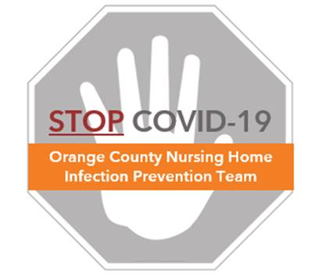

**Preventing COVID-19 in Nursing Homes**

**Overview – Cleaning Guidelines**

**Cleaning Guidance**

* Supervisors should teach housekeepers a cleaning routine where each room is cleaned in the same way
* Teach cleaning from clean to dirty. For example:
  + Clean resident room before bathroom
  + In bathroom, clean sink before toilet
  + Clean standard resident rooms before contact precaution rooms
  + In a standard resident room, start cleaning with less-frequently touched objects (such as light switch) and then move closer to objects near the residents (such as over bed table and remotes)
  + See example in “Protocol – Resident Room Cleaning”
* Help housekeepers with visual reminders:
  + Assign a specific color cleaning cloth for different room types
  + This helps prevent cleaning cloths from mixing between areas that have different amounts and types of germs
  + Example: green for bedroom, blue for bathroom, purple for common areas

**General Cleaning Sequence**

1. Perform hand hygiene and don gloves
2. Fold cleaning cloth in a way that creates multiple sides that can be used
   1. Fold in half, then in fold in half again (see “Protocol – Folding Cleaning Cloths”)
   2. This gives eight surfaces for cleaning
3. Fully saturate a fresh cleaning cloth in disinfectant
4. Wipe surfaces ensuring that all dirt, grime, and soilage is removed and disinfectant contact time is met
5. Rotate and unfold the cloth in order to use a fresh side for each new surface
6. When all sides of the cleaning cloth have been used, place in bag for laundering
7. Doff gloves and perform hand hygiene