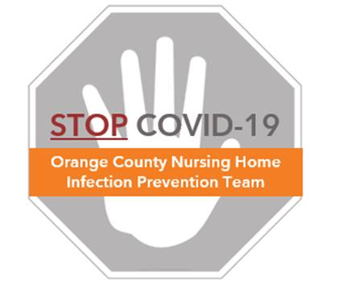

**Preventing COVID-19 in Nursing Homes**

**Overview – Housekeeping Compliance**

**Why Perform Cleaning Compliance Checks?**

**Routine checks of the quality of environmental cleaning are important**

* Checks should be done to make sure cleaning is performed correctly
* Teach housekeepers about expectations, goals, and proper protocol
* Checklists can help enforce good housekeeping

**How to Perform Compliance Checks:**

* **Visual Checks:**
  + Visual checks are quick and confirm that basic cleaning has occurred
  + Housekeeping supervisor should check rooms after they are cleaned to make sure cleaning was done properly
  + Check several rooms for each housekeeper at least once a week
  + Look to be sure the room is visually clean and tidy, and that dirt, dust, spills, stains, and trash are removed
* **Staff Observations:**
  + These observations are important to ensure proper disinfection occurs
  + Use the “Housekeeping Skills Assessment” log to watch cleaning and disinfection
  + Housekeeping supervisor should watch the housekeeper perform cleaning using a checklist for that area
  + Observe cleaning for each housekeeper at least once a week
  + Provide feedback and correction during the process
* **UV Marker Monitoring:**
  + If available, use a UV fluorescent gel to check the quality of cleaning
  + Housekeeping supervisor should place UV marks on high touch surfaces before cleaning occurs. Make sure to mark common surfaces that should be cleaned.
  + Use a black light flashlight to see if the UV marker was removed after cleaning
  + Show the housekeeper marks that were not removed
  + See “Protocol – UV Marking” for more information