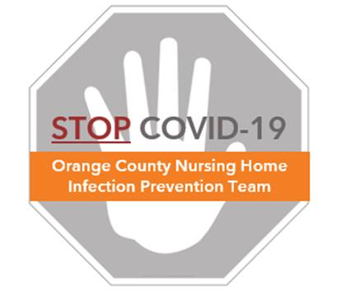

**Preventing COVID-19 in Nursing Homes**

**Protocol – Common Area Cleaning**

**Cleaning Guidance**

* Clean surfaces in a fixed order to create a cleaning routine
* Assign a specific color cleaning cloth for different room types
  + Example: green for resident room, blue for bathroom, purple for common areas
* Proceed from cleanest to dirtiest to reduce the likelihood of transferring dirt and germs from one surface to another

**Common Area Example**

* The following picture shows a clean-to-dirty sequence for cleaning a nursing station
  + **Numbers** show the order in which the surfaces are cleaned
  + **Arrows** represent the way a housekeeper will navigate through the room
  + High-touch surfaces to be cleaned are colored in **green**

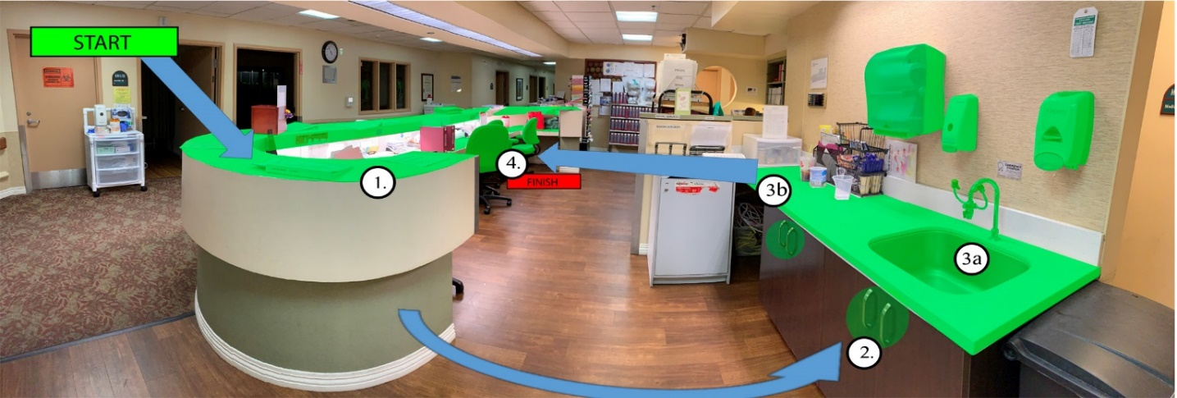

**Nursing Station Cleaning**

* High-touch surfaces in nursing stations include: countertops, cabinet handles, sink and dispensers, chairs, patient lifts, and weight scale machines

|  |  |  |
| --- | --- | --- |
| **High-touch Surfaces in Nursing Stations** | | |
| C:\Users\cberman1\Desktop\CLEAN\Cleaning Protocol\Images\TACM\Nursing Station\Countertop (2).JPG | C:\Users\cberman1\Desktop\CLEAN\Cleaning Protocol\Images\TACM\Nursing Station\Sink.JPG | C:\Users\cberman1\Desktop\CLEAN\Cleaning Protocol\Images\TACM\Nursing Station\Sink.JPG |
| Countertops | Cabinet Handles | Sink and Dispensers |
| C:\Users\cberman1\Desktop\CLEAN\Cleaning Protocol\Images\TACM\Nursing Station\Chair.JPG | C:\Users\cberman1\Desktop\CLEAN\Cleaning Protocol\Images\TACM\Nursing Station\Patient Lift.JPG | C:\Users\cberman1\Desktop\CLEAN\Cleaning Protocol\Images\TACM\Dining Room\Weight Scale.JPG |
| Chairs | Patient Lifts | Weight Scale |

* Nursing station cleaning steps:
  1. Perform hand hygiene, don fresh gloves
  2. Take a freshly saturated clean cloth and fold in half twice, so that there are 8 sides for cleaning (see “Protocol – Folding Cleaning Cloths”)
  3. Use one side of the cloth to wipe the nursing station countertops
  4. Use opposite side to wipe all cabinet handles
  5. Unfold cleaning cloth to a clean side, and wipe sink, faucet, and all dispensers
  6. With another clean side, wipe all chairs
  7. With another clean side, wipe patient lift
  8. With another clean side, wipe weight scale
  9. Remove trash can liner, then clean outside of trash can
  10. Place used cloth in linen bag
  11. Remove gloves, and wash hands with soap and water to remove any chemicals

**Shower Room Cleaning**

* High-touch surfaces in shower rooms include: light switch, door handle, shelves, wall handrails, shower fixtures, shower chair

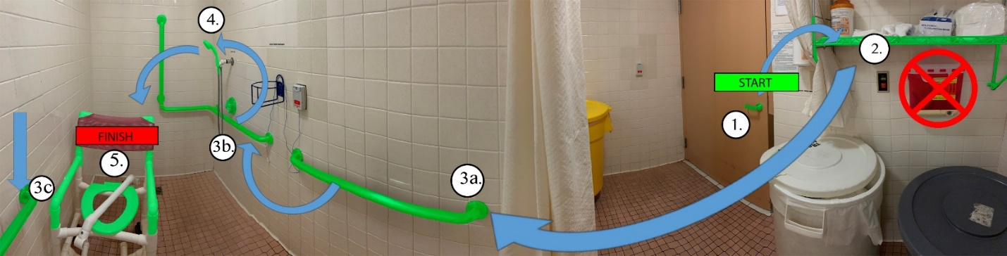

|  |  |  |
| --- | --- | --- |
| **High-touch Surfaces in Shower Rooms** | | |
| C:\Users\cberman1\Desktop\CLEAN\Cleaning Protocol\Images\TACM\Bathroom\Lightswitch.JPG | C:\Users\cberman1\Desktop\CLEAN\Cleaning Protocol\Images\TACM\Shower\IMG_2062.JPG | C:\Users\cberman1\Desktop\CLEAN\Cleaning Protocol\Images\TACM\Bathroom\Handrail 2.JPG |
| Door Knob and Light Switch | Shelving | Wall Handrails |
| C:\Users\cberman1\Desktop\CLEAN\Cleaning Protocol\Images\TACM\Bathroom\Shower Fixtures.JPG | C:\Users\cberman1\Desktop\CLEAN\Cleaning Protocol\Images\TACM\Bathroom\Shower Chair.JPG |  |
| Shower Fixtures | Shower Chair |

* Shower room cleaning steps:
  1. Perform hand hygiene, don fresh gloves
  2. Take a freshly saturated clean cloth and fold twice, to make 8 sides for cleaning (see “Protocol – Folding Cleaning Cloths”)
  3. Use one side of the cloth to wipe the door knob and light switch
  4. Use opposite side to wipe all shelves
  5. Unfold cleaning cloth to a clean side, and wipe all wall handrails
  6. With another clean side, wipe shower fixtures and shower head
  7. With another clean side, wipe shower chair
  8. With another clean side, wipe any additional items
  9. Place used cloth in linen bag, remove gloves, and wash hands with soap and water to remove any chemicals

**Therapy Room Cleaning**

* High-touch surfaces in therapy rooms include: light switch, door handle, exercise bike, therapy bed, tables and countertops, cabinet handles, stools and chairs

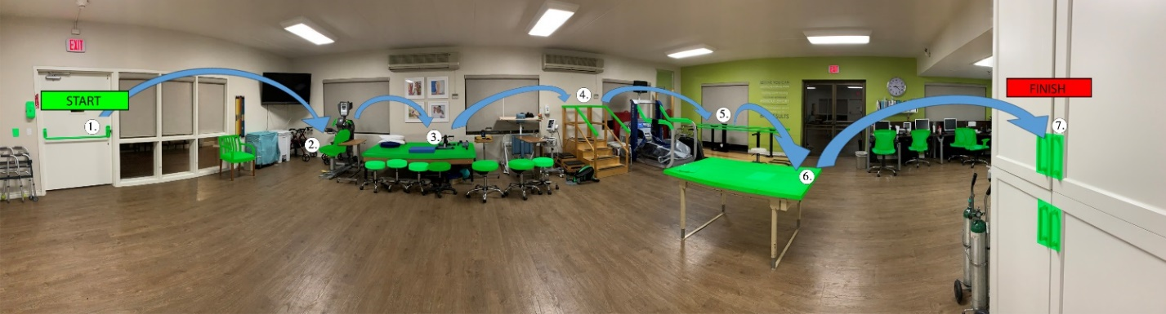

|  |  |  |
| --- | --- | --- |
| **High-touch Surfaces in Therapy Rooms** | | |
| C:\Users\cberman1\Desktop\CLEAN\Cleaning Protocol\Images\TACM\Therapy Room\Door Handle - Light Switch.JPG | C:\Users\cberman1\Desktop\CLEAN\Cleaning Protocol\Images\TACM\Therapy Room\Recumbent Bike.JPG | C:\Users\cberman1\Desktop\CLEAN\Cleaning Protocol\Images\TACM\Therapy Room\Therapy Bed (2).JPG |
| Door Knob and Light Switch | Exercise Bikes | Therapy Bed and other Equipment |
| C:\Users\cberman1\Downloads\IMG_3221.JPG | C:\Users\cberman1\Desktop\CLEAN\Cleaning Protocol\Images\TACM\Therapy Room\Cabinets.JPG | C:\Users\cberman1\Desktop\CLEAN\Cleaning Protocol\Images\TACM\Therapy Room\Stools.JPG |
| Tables and Counters | Cabinet Handles | Stools and Chairs |

* Therapy room cleaning steps:
  1. Perform hand hygiene, don fresh gloves
  2. Take a freshly saturated clean cloth and fold twice, to make 8 sides for cleaning (see “Protocol – Folding Cleaning Cloths”)
  3. Use one side of the cloth to wipe the door knob and light switch
  4. Use opposite side to wipe all shelves
  5. Unfold cleaning cloth to a clean side, and wipe all wall handrails
  6. With another clean side, wipe shower fixtures and shower head
  7. With another clean side, wipe shower chair
  8. With another clean side, wipe any additional items
  9. Place used cloth in linen bag, remove gloves, and wash hands with soap and water to remove any chemicals

**Dining Room or Activity Room Cleaning**

* High-touch surfaces in dining rooms or activity rooms include, but are not limited to: light switch, door handle, sink and countertop, tables, chairs

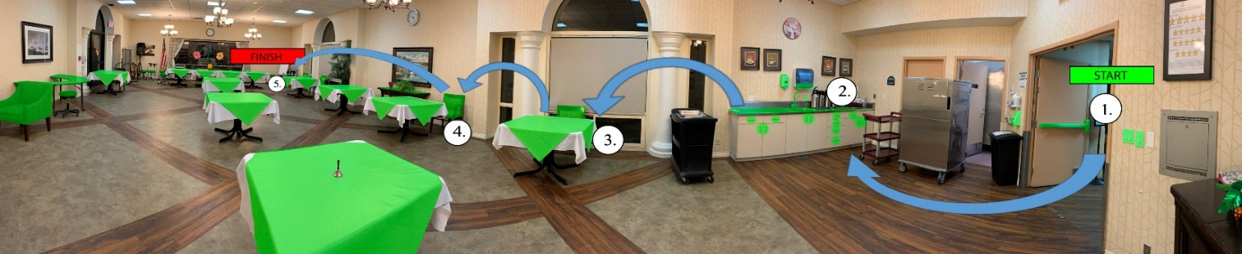

|  |  |
| --- | --- |
| **High-touch Surfaces in Dining Rooms or Activity Rooms** | |
| C:\Users\cberman1\Desktop\CLEAN\Cleaning Protocol\Images\OHAW\Conference Room\Lightswitch and Door.JPG | C:\Users\cberman1\Desktop\CLEAN\Cleaning Protocol\Images\TACM\Dining Room\Countertop.JPG |
| Door Knob and Light Switch | Sink and Countertop |
| C:\Users\cberman1\Desktop\CLEAN\Cleaning Protocol\Images\TACM\Dining Room\Tables and Chairs.JPG | C:\Users\cberman1\Downloads\IMG_2106.JPG |
| Tables | Chairs |

* Dining room or activity room cleaning steps:
  1. Perform hand hygiene, don fresh gloves
  2. Take a freshly saturated clean cloth and fold twice, to make 8 sides for cleaning (see “Protocol – Folding Cleaning Cloths”)
  3. Using a fresh side of cleaning cloth, wipe the door knob and light switch
  4. Using the opposite side, wipe sink, dispensers, and all countertops
  5. Unfold cloth to a fresh side, and wipe all dining tables
  6. Use another clean side to wipe dining chairs
  7. Use another clean side to wipe any additional items
  8. Place used cloth in linen bag, remove gloves, and wash hands with soap and water to remove any chemicals

**Conference Room Cleaning**

* High-touch surfaces in conferences room include: light switch, door handle, media cabinets, all tables, all chairs

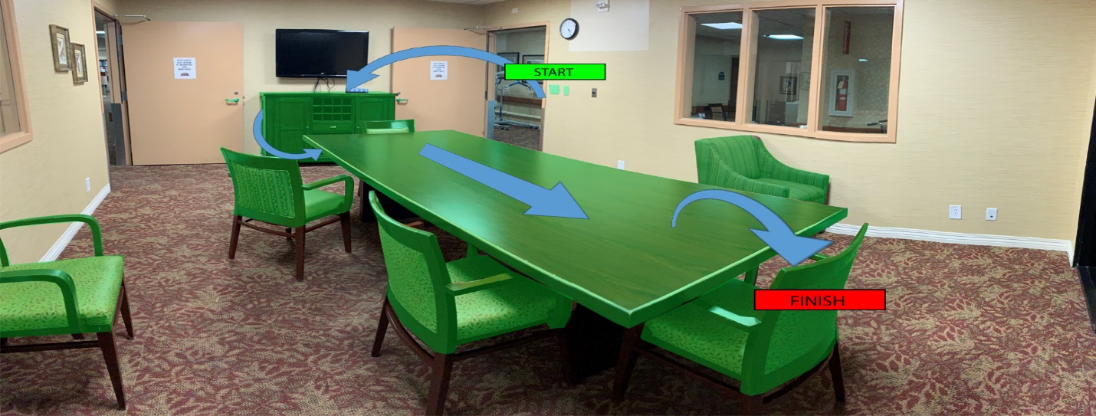

|  |  |
| --- | --- |
| **High-touch Surfaces in Conference Rooms** | |
| C:\Users\cberman1\Desktop\CLEAN\Cleaning Protocol\Images\TACM\Conference Room\Lightswitch.JPG | C:\Users\cberman1\Desktop\CLEAN\Cleaning Protocol\Images\TACM\Conference Room\Cabinets.JPG |
| Door Knob and Light Switch | Media Cabinets |
| C:\Users\cberman1\Desktop\CLEAN\Cleaning Protocol\Images\TACM\Conference Room\Chairs.JPG | C:\Users\cberman1\Desktop\CLEAN\Cleaning Protocol\Images\TACM\Conference Room\Tables.JPG |
| Chairs | Tables |

* Conference room cleaning steps:
  1. Perform hand hygiene, don fresh gloves
  2. Take a freshly saturated clean cloth and fold twice, to make 8 sides for cleaning (see “Protocol – Folding Cleaning Cloths”)
  3. Using a fresh side of cleaning cloth, wipe the door knob and light switch
  4. Using the opposite side, wipe media cabinets
  5. Unfold cloth to a fresh side, and wipe all tables
  6. Use another clean side to wipe all tables
  7. Use another clean side to wipe any additional items
  8. Place used cloth in linen bag, remove gloves, and wash hands with soap and water to remove any chemicals